
COLLEGE OF SCIENCE AND TECHNOLOGY
SCHOOL OF ICT
DEPARTMENT OF COMPUTER AND SOFTWARE ENGINEERING
ColdChain Sentinel: Resilient IoT Solution with Proactive Cooling and Environmental Monitoring for Vaccine Safety in Rural Rwanda.

A Thesis Submitted in Fulfillment of the Requirements for the Award of a Bachelor of Science in Computer and Software Engineering at the University of Rwanda.
Students’ names | Registration number
Samantha UWIHIRWE ISIMBI | 222014204
Emmanuel TUYISENGE | 222005316

Main supervisor: Mr. Joseph TWAYIGIRA
Co-supervisor: Mrs. Joselyne MUNEZERO
Academic year 2025-2026

PROJECT ID: CSE/FTY4/26/10

DECLARATION
We hereby declare that this thesis, entitled “ColdChain Sentinel: Resilient IoT Solution with Proactive Cooling and Environmental Monitoring for Vaccine Safety in Rural Rwanda”, is the result of our own work and research. This thesis has not been submitted previously for any degree or examination at any other institution.
We certify that the work presented in this thesis is original and that all ideas, data, and content not attributed to another source are our own. We have conducted this research in accordance with the ethical guidelines and standards of the University of Rwanda and have adhered to all relevant academic regulations.

Signatures:
___________________ _____________________
Samantha UWIHIRWE ISIMBI Emmanuel TUYISENGE
Ref.No: 222014204 Ref.No: 222005316

Supervisors:
____________________ ______________________________
Mr. Joseph TWAYIGIRA Mrs. Joselyne MUNEZERO
Date: .…./……/…………. Date: .…./……/………….

ACKNOWLEDGMENT
We would like to express our deepest gratitude to all those who have supported and guided us throughout the completion of this thesis.
First and foremost, we extend our heartfelt thanks to our supervisors, Joseph TWAYIGIRA and Joselyne MUNEZERO, for their continuous support, encouragement, and insightful feedback. Their expertise and guidance have been invaluable in shaping this research and bringing this project to fruition.
Our sincere appreciation goes to our families and friends for their unwavering support and understanding throughout this journey. Their encouragement and patience have been a constant source of strength for us.

DEDICATION
This thesis is dedicated to our parents, for their sacrifices and belief in us, and to our friends, for their constant encouragement and understanding.
To our families, whose love and support have been our foundation throughout our academic journey.

ABSTRACT
Maintaining vaccines within the World Health Organization (WHO) recommended temperature range of 2°C–8°C remains a major challenge in rural dispensaries and health posts in Rwanda due to frequent power outages, inadequate monitoring systems, and unfavorable environmental conditions. These challenges often lead to vaccine spoilage, increased healthcare costs, and reduced effectiveness of immunization programs. This study aims to develop ColdChain Sentinel, an Artificial Intelligence (AI)-enhanced Internet of Things (IoT) system for predictive monitoring and smart vaccine preservation in low-resource healthcare environments. The proposed system integrates temperature, humidity, and air quality sensors connected to an ESP32 microcontroller for real-time environmental monitoring, cloud-based data transmission, automatic cooling control, and AI-driven predictive analysis. Using historical and real-time sensor data, the AI module forecasts potential temperature instability and storage risks over short-term and medium-term periods of up to seven days. In addition, the system incorporates Sentinel AI, an intelligent chatbot powered by a large language model that provides healthcare workers with instant information and guidance on vaccine storage requirements, handling procedures, cold chain maintenance, temperature excursion management, and vaccine safety recommendations. The chatbot assists users by answering questions related to different vaccine types and recommending appropriate storage conditions and corrective actions when abnormalities occur. The system also generates proactive alerts and risk-level notifications to support preventive decision-making by healthcare workers. The expected results include improved vaccine safety, reduced spoilage, enhanced cold chain reliability, faster response to environmental risks, and improved access to vaccine management knowledge.

Keywords: ColdChain, Internet of Things (IoT), Artificial Intelligence (AI), Vaccine Preservation, Predictive Monitoring, AI Chatbot, Environmental Monitoring, Smart Healthcare.

CONTENTS
DECLARATION i
ACKNOWLEDGMENT ii
DEDICATION iii
ABSTRACT iv
CONTENTS v
LIST OF ABBREVIATIONS viii
TABLE OF FIGURES ix
LIST OF TABLES x
CHAPTER 1: INTRODUCTION 1
1.1 BACKGROUND OF THE STUDY 1
1.2 PROBLEM STATEMENT 2
1.3 OBJECTIVES 3
1.3.1 General Objective 3
1.3.2 Specific Objectives 3
1.4 PROPOSED SOLUTION 4
1.5 SCOPE OF THIS STUDY 4
1.6 RESEARCH MOTIVATION/RATIONAL 5
1.7 RESEARCH QUESTIONS 5
1.8 HYPOTHESIS 5
1.8.1 Primary Hypothesis (Hp) 5
1.8.2 Null Hypothesis (H₀) 5
1.8.3 Alternative Hypothesis (H₁) 6
CHAPTER 2: LITERATURE REVIEW 7
2.1 VACCINE COLD CHAIN SYSTEMS 7
2.2 INTERNET OF THINGS (IOT) IN HEALTHCARE MONITORING SYSTEMS 9
2.3 ARTIFICIAL INTELLIGENCE IN PREDICTIVE HEALTHCARE SYSTEMS 12
2.4 CLOUD COMPUTING IN HEALTHCARE MONITORING SYSTEMS 14
2.5 ENVIRONMENTAL MONITORING TECHNOLOGIES IN COLD CHAIN SYSTEMS 15
2.6 EXISTING SYSTEMS, COMPARATIVE ANALYSIS, AND RESEARCH GAPS 17
CHAPTER 3: RESEARCH METHODOLOGY 20
3.2 DATA COLLECTION 20
3.2.1 Primary Data 20
3.2.2 Secondary Data 20
3.2.3 Sample Size 20
3.2.4 Data Description 21
3.3 HARDWARE AND SOFTWARE REQUIREMENTS 21
3.3.1 Hardware Requirements 21
3.3.2 Software Requirements 22
3.4 PROPOSED ARCHITECTURE 22
3.5 SYSTEM REQUIREMENTS 23
3.5.1 Functional Requirements 23
3.5.2 Non-Functional Requirements 23
3.6 PROJECT DEVELOPMENT METHODOLOGY 24
3.7 IMPLEMENTATION TIMELINE 24
CHAPTER 4: DESIGN AND IMPLEMENTATION 26
4.1 SYSTEM ARCHITECTURE 26
4.2 SYSTEM ACTORS 27
4.3 FUNCTIONAL DESIGN 28
4.4 DATABASE DESIGN 29
4.5 USER INTERFACE IMPLEMENTATION 30
4.5.1 Dashboard Page 30
4.5.2 Health Centers Page 31
4.5.3 Refrigerators and Freezers Page 32
4.5.4 IoT Devices Page 32
4.5.5 Vaccine Inventory Page 33
4.5.6 Live Monitoring Page 33
4.5.7 Alerts Page 34
4.5.8 AI Prediction Page 34
4.5.9 Reports Page 35
4.5.10 Users Page 35
4.6 SENTINEL AI CHATBOT 36
4.7 TEMPERATURE PREDICTION MODULE 37
4.8 HARDWARE IMPLEMENTATION 37
CHAPTER 5: DISCUSSION OF THE RESULTS 39
5.1 DISCUSSION OF PARAMETERS USED AND THEIR UNITS 39
5.2 DISCUSSION OF RESULTANT 39
5.2.1 Data Preprocessing 39
5.2.2 Training and Validation Accuracy 40
5.2.3 Training and Validation Loss 40
5.2.4 Prediction Results 41
5.2.5 Comparison of Prediction Models 42
5.3 DISCUSSION OF SYSTEM FUNCTIONAL RESULTS 42
5.3.1 Web Authentication 42
5.3.2 Dashboard Monitoring 43
5.3.3 Vaccine Inventory Management 43
5.3.4 Alert Management 44
5.3.5 IoT Monitoring Performance 44
5.3.6 Sentinel AI Chatbot Performance 44
5.3.7 AI Clinical Advisory Generation 45
5.4 DISCUSSION OF OVERALL OUTCOMES 45
5.5 SUMMARY OF THE PROPOSED PRODUCT 46
CHAPTER 6: CONCLUSION AND RECOMMENDATION 47
6.1 CONCLUSION 47
6.2 RECOMMENDATIONS 47
REFERENCES 48
APPENDICES 52

LIST OF ABBREVIATIONS
AI : Artificial Intelligence
ANN : Artificial Neural Network
API : Application Programming Interface
ARIMA : Autoregressive Integrated Moving Average
DL : Deep Learning
DHT22 : Digital Humidity and Temperature Sensor (model 22)
ESP32 : Espressif Systems 32-bit Microcontroller
FK : Foreign Key
ICT : Information and Communication Technology
IoT : Internet of Things
LCD : Liquid Crystal Display
LSTM : Long Short-Term Memory
MAE : Mean Absolute Error
ML : Machine Learning
MongoDB : Document-oriented NoSQL Database System
MQ135 : Air Quality Gas Sensor (model 135)
MSE : Mean Squared Error
PK : Primary Key
RH : Relative Humidity
RMSE : Root Mean Squared Error
SMS : Short Message Service
UR : University of Rwanda
VS Code : Visual Studio Code
WHO : World Health Organization
Wi-Fi : Wireless Fidelity
WSN : Wireless Sensor Network
°C : Degrees Celsius

TABLE OF FIGURES
Figure 2 Agile methodology 24
Figure 3 Architecture of the ColdChain Sentinel system 27
Figure 4 UseCase Diagram of coldchain sentinel 28
Figure 5 Database schema of the system 30
Figure 6 dashboard interface 31
Figure 7 Health Centers page. 31
Figure 8 refrigerator management interface 32
Figure 9 IoT Devices interface 32
Figure 10 Vaccine management interface 33
Figure 11 Live monitoring interface 33
Figure 12 The alerts interface 34
Figure 13 AI prediction interface 34
Figure 14 Reports interface 35
Figure 15 User management interface 35
Figure 16 Sentinel AI chatbot interface 36
Figure 17 The architecture of the prediction model 37
Figure 18 Circuit diagram of device 38
Figure 19 hardware prototype of coldchain sentinel system 38
Figure 20 Data Preprocessing Workflow 40
Figure 21 Training and Validation Accuracy Graph 40
Figure 22 Training and Validation Loss Graph 41
Figure 23 Actual versus Predicted Temperature Graph 41
Figure 24 Login Interface 42
Figure 25 Dashboard Interface 43
Figure 26 Vaccine Inventory Interface 43
Figure 27 Alert Notification Interface 44
Figure 28 Sentinel AI Chatbot Interface 45

LIST OF TABLES
Table 1 Summary of Existing Vaccine Cold Chain Studies 9
Table 2 Summary of IoT-Based Healthcare Monitoring Studies 11
Table 3 Summary of AI-Based Predictive Healthcare Studies 14
Table 4 Summary of Environmental Monitoring Technologies 17
Table 5 Identified Research Gaps 19
Table 6 Hardware Components 21
Table 7 Software Components 22
Table 8 Implementation Timeline 25
Table 9 Comparison of Prediction Models 42

CHAPTER 1: INTRODUCTION
This chapter introduces the ColdChain Sentinel study, which focuses on improving vaccine storage in rural health facilities in Rwanda. It highlights challenges such as power outages and poor monitoring that affect vaccine safety. It also presents an AI-enhanced IoT system designed for real-time monitoring, prediction, and protection of vaccine storage conditions.

1.1 BACKGROUND OF THE STUDY
Vaccines are among the most important tools used to prevent infectious diseases and improve public health. However, vaccines are highly sensitive biological products that require proper storage conditions to remain effective. According to the World Health Organization (WHO), most vaccines must be stored within a temperature range of 2°C–8°C throughout the cold chain process [6]. Exposure to temperatures outside this recommended range can reduce vaccine potency, resulting in spoilage, financial losses, and reduced effectiveness of immunization programs.
Maintaining proper cold chain conditions remains a major challenge in many developing countries, especially in rural healthcare facilities where infrastructure is limited. In Rwanda, dispensaries and health posts often experience unstable electricity supply, insufficient monitoring systems, and harsh environmental conditions that threaten vaccine preservation [3][5]. Frequent power outages and inadequate supervision can expose vaccines to unsafe temperatures for long periods without immediate detection. A study conducted in the Eastern Province of Rwanda reported that several healthcare facilities face difficulties in maintaining cold chain storage conditions according to WHO standards [5].
Traditional vaccine storage systems mainly rely on manual temperature monitoring methods where healthcare workers periodically check and record refrigerator temperatures [2]. Although this approach is widely used, it does not provide continuous monitoring or instant response during sudden environmental changes. Recent advancements in Internet of Things (IoT) technologies have introduced automated monitoring systems capable of collecting and transmitting environmental data in real time [7]. IoT-based healthcare systems use sensors, cloud platforms, and communication technologies to improve monitoring efficiency and remote supervision [8].
Despite these technological improvements, many existing systems remain reactive rather than preventive. Most systems only notify healthcare workers after unsafe conditions have already occurred [2][3]. In addition, many monitoring systems focus mainly on temperature while neglecting other environmental factors such as humidity, air quality, and cooling system efficiency that may affect vaccine storage conditions. Healthcare workers in rural facilities may also have limited access to immediate technical guidance regarding vaccine storage requirements, handling procedures, and corrective actions during temperature excursions.
Recent developments in Artificial Intelligence (AI) have created opportunities for predictive healthcare systems capable of forecasting risks before they occur. AI can analyze historical and real-time data to identify patterns and predict future environmental changes [1]. Furthermore, AI-powered conversational assistants can provide instant support and guidance to healthcare workers by answering questions related to vaccine storage, cold chain management, and vaccine safety. Integrating AI with IoT monitoring systems can therefore improve vaccine preservation by enabling proactive intervention instead of reactive response while also improving access to expert knowledge.
This study proposes ColdChain Sentinel, an AI-enhanced IoT system designed for predictive monitoring and smart vaccine preservation in rural dispensaries and health posts. The proposed system combines environmental sensing, cloud-based monitoring, automatic cooling mechanisms, AI-powered predictive analytics, and an intelligent chatbot called Sentinel AI. The chatbot assists healthcare workers by providing information on vaccine storage requirements, handling procedures, cold chain maintenance, temperature excursion management, and vaccine safety recommendations. Together, these technologies aim to improve vaccine safety, reduce spoilage, strengthen cold chain reliability, and support informed decision-making in low-resource healthcare environments [8][9].

1.2 PROBLEM STATEMENT
Maintaining safe vaccine storage conditions remains a significant challenge in rural dispensaries and health posts in Rwanda. Vaccines require continuous storage within the World Health Organization (WHO) recommended temperature range of 2°C–8°C to preserve their effectiveness and safety [6]. However, many rural healthcare facilities experience frequent power outages, inadequate refrigeration infrastructure, and limited monitoring systems that expose vaccines to unsafe environmental conditions [3][5].
Most healthcare facilities still rely on manual temperature monitoring methods that do not provide continuous supervision or immediate response during sudden temperature changes [2]. As a result, vaccines may remain exposed to unsafe temperatures for long periods before healthcare workers detect the problem. This increases the risk of vaccine spoilage, financial losses, and reduced effectiveness of immunization programs. In addition, poor environmental conditions such as high humidity, dust, and poor air quality may affect cooling system performance and further compromise vaccine preservation [3].
Although some existing IoT-based systems provide real-time monitoring and alert generation, many of them remain reactive rather than preventive [2][7]. These systems mainly notify users after unsafe conditions have already occurred, leaving limited opportunity for preventive action. Furthermore, most current cold chain systems lack predictive intelligence capable of forecasting future temperature instability or identifying patterns that may lead to vaccine storage failure. Healthcare workers may also face difficulties accessing immediate information regarding vaccine storage requirements, handling procedures, and corrective actions during temperature excursions, especially in remote healthcare facilities.
There is therefore a need for an intelligent and proactive vaccine preservation system capable of continuously monitoring environmental conditions, automatically responding to unsafe situations, predicting future storage risks before vaccine damage occurs, and providing instant guidance on vaccine storage and cold chain management. This study addresses these challenges by proposing ColdChain Sentinel, an AI-enhanced IoT system that integrates real-time environmental monitoring, cloud-based supervision, automatic cooling control, predictive analytics, and an AI-powered chatbot to improve vaccine safety and support informed decision-making in rural healthcare facilities [8][9].

1.3 OBJECTIVES

1.3.1 General Objective
The main aim of this research project is to develop ColdChain Sentinel, an AI-enhanced IoT-based solution designed for predictive monitoring of temperature, humidity, and air quality in real time, with a proactive cooling backup system. The system aims to ensure the safe storage of vaccines in rural health centers and dispensaries by providing continuous monitoring, early risk prediction, intelligent decision support, and timely response to environmental changes.

1.3.2 Specific Objectives
The specific objectives for the ColdChain Sentinel project are:
1. To conduct research and analyze the challenges faced in vaccine storage and cold chain management in rural health centers and dispensaries in Rwanda.
2. To design and develop an IoT-based system prototype for continuous monitoring of temperature, humidity, and external air quality in vaccine storage environments.
3. To implement and test a proactive cooling system, cloud dashboard with an AI-powered chatbot, and alert mechanism for real-time monitoring and quick response to unsafe conditions.
4. To evaluate the effectiveness of the ColdChain Sentinel system in improving vaccine safety and reducing the risk of vaccine spoilage in rural health facilities.

1.4 PROPOSED SOLUTION
This research proposes ColdChain Sentinel, an AI-enhanced IoT system designed to ensure safe vaccine preservation through intelligent environmental monitoring and predictive risk analysis.
The proposed system integrates environmental sensors, including temperature, humidity, and air quality sensors, connected to an ESP32 microcontroller for continuous real-time data collection. The collected data is transmitted to a cloud platform where it is stored, processed, and analyzed.
Unlike conventional cold chain systems that only provide reactive monitoring, the proposed system incorporates an Artificial Intelligence prediction module capable of analyzing historical and real-time environmental data to forecast potential temperature instability and storage risks. The AI model provides both short-term predictions and medium-term risk forecasting of up to seven days.
Additionally, the system includes an automatic cooling backup mechanism that activates whenever unsafe temperature conditions are detected. Healthcare workers and administrators can remotely supervise storage conditions through a web-based dashboard that displays live sensor readings, predictive insights, risk levels, and emergency alerts.
The integration of IoT sensing, AI prediction, cloud monitoring, and proactive cooling creates an intelligent vaccine preservation system capable of improving healthcare reliability in low-resource rural environments.

1.5 SCOPE OF THIS STUDY
This study focuses on the design, development, and testing of a prototype AI-enhanced IoT system for vaccine preservation in rural dispensaries and health posts.
The research covers:
- Real-time monitoring of temperature, humidity, and air quality
- AI-based prediction of future temperature risks
- Automatic cooling activation
- Cloud-based data storage and dashboard visualization
- Alert and notification mechanisms
The study is limited to prototype implementation and simulated testing environments. Large-scale deployment across national healthcare infrastructure is outside the scope of this research.

1.6 RESEARCH MOTIVATION/RATIONAL
This research is motivated by the growing need to improve vaccine safety and healthcare reliability in rural communities where cold chain infrastructure remains vulnerable to environmental and electrical instability. The integration of AI with IoT technologies offers an opportunity to shift vaccine preservation systems from reactive monitoring toward predictive and preventive healthcare solutions. By enabling early detection of storage risks, the proposed system can support healthcare workers in protecting vaccines before damage occurs.
Academically, this research also contributes to the growing field of intelligent healthcare systems by demonstrating how AI-driven predictive analytics can be applied in low-resource healthcare environments to improve operational efficiency and public health outcomes.

1.7 RESEARCH QUESTIONS
1. What are the main challenges affecting vaccine storage and cold chain management in rural health centers and dispensaries in Rwanda?
2. How can IoT technologies improve real-time monitoring of temperature, humidity, and air quality in vaccine storage environments?
3. How can a proactive cooling system, cloud dashboard with chatbot, and alert mechanism be implemented and tested to provide real-time monitoring and rapid response to unsafe conditions?
4. How effective is the ColdChain Sentinel system in improving vaccine safety and reducing the risk of vaccine spoilage in rural health facilities?

1.8 HYPOTHESIS

1.8.1 Primary Hypothesis (Hp)
The integration of Internet of Things (IoT) monitoring, Artificial Intelligence (AI)-based predictive analytics, cloud-based supervision, and automatic cooling control in the ColdChain Sentinel system will improve vaccine preservation by enhancing environmental monitoring, reducing storage risks, and supporting proactive decision-making in rural healthcare facilities.

1.8.2 Null Hypothesis (H₀)
The integration of Internet of Things (IoT) monitoring, Artificial Intelligence (AI)-based predictive analytics, cloud-based supervision, and automatic cooling control in the ColdChain Sentinel system will not significantly improve vaccine preservation, environmental monitoring, or storage risk management in rural healthcare facilities.

1.8.3 Alternative Hypothesis (H₁)
The integration of Internet of Things (IoT) monitoring, Artificial Intelligence (AI)-based predictive analytics, cloud-based supervision, and automatic cooling control in the ColdChain Sentinel system will significantly improve vaccine preservation, environmental monitoring, and storage risk management in rural healthcare facilities.

CHAPTER 2: LITERATURE REVIEW
This chapter reviews existing studies on vaccine cold chain management, IoT healthcare monitoring, AI prediction systems, and cloud-based healthcare platforms. It discusses their strengths, limitations, and the gaps in current solutions. It also explains how the proposed ColdChain Sentinel system improves vaccine preservation in rural health facilities.

2.1 VACCINE COLD CHAIN SYSTEMS
A vaccine cold chain refers to the system used to store, transport, and handle vaccines within recommended temperature conditions from production until administration. Maintaining an effective cold chain is essential because vaccines are highly sensitive biological products that can lose their potency when exposed to temperatures outside the recommended range. According to the World Health Organization, most vaccines must be maintained between 2°C and 8°C throughout storage and handling processes to preserve their effectiveness [6]. Exposure to freezing temperatures or excessive heat can permanently damage vaccines, leading to reduced immunization effectiveness and increased vaccine wastage.
Globally, maintaining vaccine cold chain systems remains a major public health challenge, particularly in low-resource healthcare environments. A recent study by Jiang et al. (2024) explained that temperature instability during vaccine storage continues to affect healthcare systems despite advancements in digital monitoring technologies. The study emphasized that many healthcare facilities still experience delays in detecting temperature anomalies, resulting in vaccine losses and operational inefficiencies [10]. Similarly, Ali and Khan (2023) observed that cold chain disruptions remain common in developing regions due to poor infrastructure, inadequate supervision, and unstable electricity supply [11].
In Rwanda, vaccine preservation remains particularly challenging in rural dispensaries and health posts where healthcare infrastructure is limited. Nyirimanzi et al. [5] assessed medicine cold chain storage conformity in health facilities of the Eastern Province of Rwanda and reported that several facilities failed to maintain WHO-recommended storage conditions consistently. Their findings identified inadequate refrigeration systems, insufficient monitoring practices, and frequent electricity interruptions as major contributors to cold chain failure [5]. These findings demonstrate that maintaining vaccine safety remains a critical concern in rural healthcare environments.
Traditionally, many healthcare facilities rely on manual temperature monitoring methods where healthcare workers periodically inspect refrigerators and manually record temperatures [2]. Although manual monitoring systems are relatively affordable and easy to implement, they provide limited supervision and are unable to detect sudden temperature fluctuations in real time. Kalisa and Tuyisenge [2] noted that manual monitoring methods increase the risk of delayed intervention, especially during power outages or refrigeration failures. Similar findings were reported by Uwonkunda [3], who highlighted that delayed detection of unsafe storage conditions contributes significantly to vaccine spoilage in healthcare facilities.
To address these challenges, recent studies have proposed digital vaccine monitoring systems based on Internet of Things (IoT) technologies. IoT-based cold chain systems integrate sensors, communication technologies, and cloud platforms to support continuous environmental monitoring and automated alerts [7]. Ben-Daya et al. [7] explained that IoT technologies improve supply chain visibility by enabling real-time monitoring and remote supervision of environmental conditions. These systems reduce dependence on manual supervision and improve response time during storage anomalies.
Several researchers have implemented IoT-based cold chain monitoring systems for healthcare applications. Tang et al. [4] developed a temperature and humidity monitoring system using Arduino-based sensors for cold storage environments. Their system demonstrated improved monitoring accuracy and automated environmental supervision compared to traditional manual methods. Similarly, Kumar and Verma [8] proposed a cloud-enabled IoT healthcare monitoring framework capable of transmitting environmental data in real time and generating automated alerts. Their study showed that cloud-integrated systems improve healthcare monitoring efficiency and support remote supervision.
Despite these technological advancements, many existing vaccine monitoring systems remain reactive rather than preventive. Most systems focus on detecting and reporting unsafe conditions after they occur rather than predicting future risks before vaccine damage happens [2][3]. In addition, many existing studies primarily focus on temperature monitoring while overlooking other environmental factors such as humidity, air quality, and cooling system performance that may influence vaccine preservation.
Recent advancements in Artificial Intelligence (AI) have introduced opportunities for predictive cold chain management systems capable of forecasting future environmental conditions and supporting preventive intervention. Harrabi et al. (2024) demonstrated that AI-based anomaly detection systems can significantly improve predictive monitoring performance in smart healthcare environments by identifying patterns associated with environmental instability [12]. Similarly, Alex, Anna, and Peter [1] showed that integrating AI with IoT technologies improves predictive analysis and operational efficiency in environmental monitoring applications.
Although existing studies demonstrate the effectiveness of IoT technologies in healthcare monitoring, there remains limited research on AI-enhanced predictive vaccine preservation systems specifically designed for rural healthcare facilities in Rwanda. Most current systems lack intelligent forecasting capabilities capable of anticipating future storage risks before unsafe conditions occur.
Table 1 Summary of Existing Vaccine Cold Chain Studies
System | Real-Time Monitoring | Cloud Support | AI Prediction | Automatic Response | Rural Healthcare Focus
Kalisa & Tuyisenge [2] | yes | no | no | no | yes
Uwonkunda [3] | yes | no | no | no | yes
Tang et al. [4] | yes | no | no | no | yes
Kumar & Verma [8] | yes | no | Partial | no | yes
Proposed System (ColdChain Sentinel) | yes | yes | yes | yes | yes

2.2 INTERNET OF THINGS (IOT) IN HEALTHCARE MONITORING SYSTEMS
The Internet of Things (IoT) refers to a network of interconnected devices capable of collecting, transmitting, and processing data through internet connectivity. IoT technologies have significantly transformed healthcare systems by enabling real-time monitoring, remote supervision, automation, and intelligent decision-making. In healthcare environments, IoT systems integrate sensors, communication technologies, cloud platforms, and data analytics tools to improve operational efficiency and patient care [7].
Recent advancements in IoT technologies have expanded their applications in healthcare monitoring systems, including patient monitoring, medical equipment management, environmental sensing, and vaccine cold chain supervision. Ben-Daya et al. [7] explained that IoT technologies improve supply chain visibility and operational efficiency through continuous data collection and automated communication between devices. Their study emphasized that IoT systems reduce manual intervention and improve monitoring accuracy in sensitive environments.
In vaccine cold chain management, IoT systems are increasingly used to monitor environmental conditions such as temperature, humidity, and refrigeration performance in real time. Kalisa and Tuyisenge [2] developed an IoT-based remote monitoring solution for efficient storage and delivery of temperature-sensitive vaccines in Rwanda. Their system integrated environmental sensors with cloud communication technologies to support continuous monitoring and remote supervision of vaccine storage conditions. The study demonstrated that IoT systems improve monitoring efficiency and reduce the risks associated with manual temperature recording.
Similarly, Uwonkunda [3] proposed a smart monitoring system for hospital cold rooms in Rwanda using sensor technologies and real-time data transmission. The study showed that automated monitoring systems improve responsiveness and support faster intervention during temperature instability. However, the system mainly focused on real-time monitoring and alert generation without predictive analytics capabilities.
IoT healthcare monitoring systems commonly use environmental sensors such as DHT22 temperature and humidity sensors, MQ-series gas sensors, microcontrollers, and wireless communication technologies to collect and transmit environmental data [4]. Tang et al. [4] developed a temperature and humidity monitoring system for cold storage environments using Arduino-based sensors. Their findings demonstrated that automated sensing systems improve monitoring reliability and provide more accurate environmental supervision than traditional manual approaches.
Cloud-enabled IoT architectures further improve healthcare monitoring systems by enabling centralized data storage, remote accessibility, and automated alert mechanisms. Kumar and Verma [8] proposed a cloud-enabled IoT healthcare framework capable of real-time environmental monitoring and automated alert generation. Their study demonstrated that cloud platforms improve healthcare efficiency by allowing healthcare personnel to remotely supervise environmental conditions using internet-connected devices.
Recent studies have also emphasized the importance of resilient IoT architectures in rural healthcare environments affected by unstable electricity supply and connectivity interruptions. Mwangi, Mutua, and Otieno [9] proposed resilient IoT healthcare monitoring architectures designed for low-resource environments with unreliable power systems. Their study highlighted that resilient system design improves monitoring reliability and reduces system downtime during power instability.
Despite the growing adoption of IoT technologies in healthcare systems, several limitations remain in existing monitoring solutions. Most IoT-based healthcare systems focus primarily on real-time sensing and threshold-based alerts while lacking predictive intelligence capable of forecasting future risks [2][3]. In many cases, healthcare workers are informed only after unsafe environmental conditions have already occurred. Additionally, several monitoring systems focus mainly on temperature supervision while neglecting other environmental conditions such as humidity, air quality, and cooling system efficiency.
Recent research has suggested integrating Artificial Intelligence (AI) with IoT systems to improve predictive healthcare monitoring and intelligent decision-making. AI-enhanced IoT systems can analyze historical and real-time environmental data to identify patterns, predict anomalies, and support proactive intervention [1][22]. This integration has shown promising results in environmental monitoring, agriculture, and smart infrastructure management applications.
Although existing literature demonstrates that IoT technologies improve healthcare monitoring efficiency and automation, there remains limited research on AI-enhanced IoT systems specifically designed for predictive vaccine preservation in rural healthcare facilities. Most current systems remain reactive rather than preventive and provide limited support for forecasting future storage instability.
Table 2 Summary of IoT-Based Healthcare Monitoring Studies
Author(s) | Focus Area | AI Technique | Key Contribution | Limitation
Alex et al. [1] | AI-IoT environmental monitoring | Predictive AI algorithms | Improved predictive environmental analysis | Agriculture-focused
Harrabi et al. [12] | Healthcare anomaly detection | Machine Learning | Improved anomaly detection accuracy | Not vaccine-focused
Rahman et al. [15] | Predictive healthcare monitoring | Machine Learning models | Environmental risk prediction | Complex implementation
Kumar & Verma [8] | Cloud healthcare systems | AI-assisted cloud analytics | Remote predictive healthcare supervision | Limited environmental sensing
Mwangi et al. [9] | Rural healthcare monitoring | Resilient IoT systems | Improved monitoring reliability | No advanced AI forecasting
Proposed System | Predictive vaccine preservation | AI + IoT + LSTM forecasting | Predictive risk analysis and preventive alerts | Prototype implementation stage

2.3 ARTIFICIAL INTELLIGENCE IN PREDICTIVE HEALTHCARE SYSTEMS
Artificial Intelligence (AI) refers to computer-based systems capable of simulating human intelligence through learning, reasoning, pattern recognition, and decision-making. In recent years, AI technologies have become increasingly important in healthcare systems because of their ability to analyze large amounts of data, identify hidden patterns, and support predictive decision-making. AI is widely applied in medical diagnosis, patient monitoring, healthcare automation, and predictive analytics to improve operational efficiency and healthcare outcomes [12].
One of the most important advantages of AI in healthcare monitoring systems is its ability to perform predictive analysis. Predictive AI systems use historical and real-time data to forecast future events and detect anomalies before critical failures occur. In healthcare environments, this capability is particularly valuable because early detection of risks can prevent equipment failure, improve patient safety, and reduce operational losses.
Recent studies have demonstrated the effectiveness of AI technologies in environmental monitoring and intelligent automation systems. Alex, Anna, and Peter [1] integrated AI and IoT technologies in agricultural ecosystems to improve environmental monitoring and predictive analysis. Their study showed that AI algorithms can analyze environmental patterns and forecast future conditions with improved accuracy. Although their research focused on agriculture, the findings demonstrate the potential of AI-IoT integration in predictive environmental monitoring applications.
AI technologies such as Machine Learning (ML), Deep Learning (DL), Artificial Neural Networks (ANN), Random Forest, and Long Short-Term Memory (LSTM) models are commonly used in predictive healthcare systems [12][15]. These models are capable of analyzing time-series data generated by sensors to identify trends and predict future environmental changes. LSTM models, in particular, are highly effective for sequential and time-dependent data analysis because they can learn long-term dependencies in environmental patterns.
Harrabi et al. [12] proposed an AI-based anomaly detection system for smart healthcare monitoring environments. Their study demonstrated that AI models significantly improve anomaly detection accuracy compared to traditional threshold-based monitoring approaches. The researchers concluded that predictive AI systems improve healthcare responsiveness by identifying environmental instability before system failure occurs.
Similarly, Rahman et al. (2025) developed a machine learning-based healthcare monitoring framework capable of predicting environmental risks in hospital environments using sensor-generated data [15]. Their findings showed that predictive AI models improve system reliability and reduce delayed response during abnormal environmental conditions.
In healthcare cold chain management, AI technologies are increasingly being explored to improve vaccine preservation and environmental stability. AI models can analyze temperature fluctuations, humidity patterns, equipment performance, and historical environmental data to forecast future storage risks. Such predictive capabilities can help healthcare workers take preventive actions before unsafe conditions damage vaccines.
Despite these advancements, many existing vaccine monitoring systems still rely on simple threshold-based alert systems rather than intelligent predictive models [2][3]. Most current systems only notify users after dangerous conditions have already occurred, limiting opportunities for preventive intervention. Additionally, some existing AI healthcare systems are complex, expensive, and difficult to implement in low-resource healthcare environments.
Another challenge associated with AI systems is the quality and availability of training data. Predictive AI models require sufficient historical environmental data to achieve accurate forecasting performance. In rural healthcare facilities, inconsistent monitoring infrastructure may limit data availability and affect prediction accuracy [9]. Researchers have therefore emphasized the importance of integrating resilient IoT architectures with cloud-based data collection systems to support effective AI implementation [8][30].
Recent studies have also highlighted the growing integration of AI with cloud computing and IoT technologies in smart healthcare systems. Cloud-based AI systems enable centralized processing of environmental data, remote monitoring, and scalable predictive analytics [8]. This integration improves healthcare automation and allows healthcare workers to access predictive insights remotely.
Although AI technologies have shown strong potential in healthcare monitoring and predictive analytics, there remains limited research on AI-enhanced predictive vaccine preservation systems specifically designed for rural healthcare environments in Rwanda. Most existing studies focus mainly on real-time monitoring and lack intelligent forecasting mechanisms capable of predicting future temperature instability in vaccine storage systems.

Table 3 Summary of AI-Based Predictive Healthcare Studies
Author(s) | Focus Area | AI Technique | Key Contribution | Limitation
Alex et al. [1] | AI-IoT environmental monitoring | Predictive AI algorithms | Improved predictive environmental analysis | Agriculture-focused
Harrabi et al. [12] | Healthcare anomaly detection | Machine Learning | Improved anomaly detection accuracy | Not vaccine-focused
Rahman et al. [15] | Predictive healthcare monitoring | Machine Learning models | Environmental risk prediction | Complex implementation
Kumar & Verma [8] | Cloud healthcare systems | AI-assisted cloud analytics | Remote predictive healthcare supervision | Limited environmental sensing
Mwangi et al. [9] | Rural healthcare monitoring | Resilient IoT systems | Improved monitoring reliability | No advanced AI forecasting

2.4 CLOUD COMPUTING IN HEALTHCARE MONITORING SYSTEMS
Cloud computing has become a critical component in modern healthcare monitoring systems because it enables centralized data storage, remote accessibility, scalability, and real-time communication. In IoT healthcare environments, cloud platforms facilitate the transmission, storage, and analysis of sensor-generated data from distributed monitoring devices [8].
Kumar and Verma [8] proposed a cloud-enabled IoT framework for healthcare monitoring and alert systems. Their study showed that cloud platforms improve healthcare efficiency by supporting real-time data visualization, automated alert generation, and remote supervision. Cloud computing also enables healthcare workers and administrators to access monitoring information from different locations using internet-connected devices.
Cloud-based monitoring systems are particularly important in rural healthcare environments where technical supervision may be limited. Through cloud integration, healthcare personnel can remotely monitor environmental conditions and respond quickly to unsafe storage situations.
However, cloud-enabled monitoring systems still face challenges related to internet dependency, data security, and power instability in low-resource environments [9]. Mwangi, Mutua, and Otieno [9] emphasized the importance of resilient IoT architectures capable of operating reliably under unstable power and connectivity conditions in rural healthcare settings.
The integration of cloud computing with AI and IoT technologies therefore provides opportunities for developing more resilient and intelligent healthcare monitoring systems capable of supporting predictive vaccine preservation.

2.5 ENVIRONMENTAL MONITORING TECHNOLOGIES IN COLD CHAIN SYSTEMS
Environmental monitoring technologies play a critical role in healthcare cold chain systems because environmental conditions directly affect vaccine preservation and storage stability. Vaccines are highly sensitive to changes in temperature, humidity, and surrounding environmental conditions. Continuous monitoring of these environmental parameters is therefore essential for maintaining vaccine potency and reducing storage-related risks [6].
Temperature monitoring is one of the most important components of vaccine cold chain management. According to the World Health Organization, most vaccines must remain within a storage temperature range of 2°C–8°C to maintain effectiveness [6]. Exposure to temperatures above or below this range may permanently damage vaccines and compromise immunization programs.
Traditional environmental monitoring systems in healthcare facilities commonly rely on manual thermometers and periodic inspections by healthcare workers [2]. Although these methods are simple and inexpensive, they do not provide continuous monitoring or immediate detection of environmental fluctuations. Delayed identification of unsafe conditions increases the risk of vaccine spoilage, especially in healthcare facilities affected by unstable power supply and limited supervision [5].
Recent technological advancements have introduced sensor-based environmental monitoring systems capable of collecting real-time environmental data automatically. These systems commonly integrate temperature sensors, humidity sensors, gas sensors, and wireless communication technologies to improve monitoring accuracy and responsiveness [4]. Tang et al. [4] developed a temperature and humidity monitoring system for cold storage environments using Arduino-based sensor technologies. Their study demonstrated that automated sensing systems improve monitoring precision and reduce the limitations associated with manual monitoring methods.
Temperature sensors such as the DHT22, DS18B20, and LM35 are widely used in healthcare monitoring systems because of their accuracy and low power consumption [13]. Humidity sensors are also important because excessive humidity may affect refrigeration equipment performance and contribute to environmental instability. In addition, air quality monitoring technologies are increasingly being integrated into healthcare environments to monitor factors such as dust particles, gas concentration, and ventilation quality.
Several recent studies have emphasized the importance of integrating multiple environmental sensing technologies into healthcare monitoring systems. Sharma and Singh [14] explained that multi-sensor healthcare systems improve environmental awareness and provide more comprehensive supervision compared to single-parameter monitoring systems. Their study highlighted that combining temperature, humidity, and air quality sensing technologies improves anomaly detection and healthcare responsiveness.
Wireless sensor networks and IoT communication technologies further enhance environmental monitoring systems by enabling real-time data transmission and remote accessibility [7]. IoT-enabled sensors can continuously transmit environmental data to cloud platforms where healthcare personnel can remotely monitor storage conditions and receive automated alerts during environmental instability [8].
Another important advancement in environmental monitoring systems is the integration of predictive analytics and Artificial Intelligence (AI). AI-enhanced monitoring systems can analyze environmental trends and predict future anomalies before unsafe conditions occur [12]. Predictive environmental monitoring improves preventive intervention and reduces the risks associated with delayed response during storage instability.
Despite these advancements, several existing environmental monitoring systems still face important limitations. Many systems focus mainly on temperature sensing while neglecting other environmental factors such as humidity, air quality, and cooling system performance [3][4]. In addition, some existing systems lack predictive capabilities and only provide reactive alerts after environmental anomalies occur.
Power instability and connectivity interruptions also affect environmental monitoring reliability in rural healthcare facilities [9]. Researchers have therefore emphasized the need for resilient monitoring architectures capable of operating effectively in low-resource environments.

Table 4 Summary of Environmental Monitoring Technologies
Author(s) | Monitoring Focus | Technologies Used | Key Contribution | Limitation
Tang et al. [4] | Temperature and humidity monitoring | Arduino, environmental sensors | Improved automated environmental monitoring | No cloud or AI integration
Sharma & Singh [14] | Smart healthcare monitoring | Multi-sensor IoT systems | Comprehensive healthcare sensing | Limited predictive capabilities
Ben-Daya et al. [7] | IoT environmental monitoring | IoT communication systems | Real-time monitoring and automation | General supply chain focus
Kumar & Verma [8] | Cloud healthcare systems | IoT + cloud monitoring | Remote environmental supervision | No advanced AI prediction
Harrabi et al. [12] | AI healthcare monitoring | AI anomaly detection | Improved anomaly prediction | Not focused on vaccine storage
Mwangi et al. [9] | Rural healthcare monitoring | Resilient IoT architectures | Improved reliability under unstable power | No multi-environment sensing

2.6 EXISTING SYSTEMS, COMPARATIVE ANALYSIS, AND RESEARCH GAPS
Several studies have proposed smart healthcare monitoring systems aimed at improving vaccine preservation, environmental monitoring, and cold chain supervision. These systems mainly integrate Internet of Things (IoT) technologies, environmental sensors, cloud platforms, and automated alert mechanisms to improve monitoring efficiency and reduce dependence on manual supervision [2][7]. Although these systems have significantly improved real-time monitoring capabilities, important limitations still exist regarding predictive intelligence, environmental coverage, and proactive intervention.
Kalisa and Tuyisenge [2] developed an IoT-based remote monitoring solution for efficient storage and delivery of temperature-sensitive vaccines in Rwanda. Their system integrated environmental sensors and cloud communication technologies to support real-time monitoring and remote supervision. The study demonstrated improved monitoring efficiency compared to manual approaches. However, the system mainly focused on monitoring and alert generation without predictive analytics capabilities.
Similarly, Uwonkunda [3] designed a smart monitoring system for hospital cold rooms using sensor technologies and cloud-based supervision. The proposed system improved visibility of environmental conditions and supported automated monitoring. However, the study remained limited to reactive monitoring approaches where healthcare workers were informed only after unsafe environmental conditions occurred.
Cloud-based healthcare monitoring systems have also been widely explored in recent studies. Kumar and Verma [8] proposed a cloud-enabled IoT healthcare framework capable of supporting real-time data visualization, automated alerts, and remote supervision. Their findings showed that cloud computing improves healthcare responsiveness and centralized monitoring efficiency. However, the study provided limited focus on predictive environmental forecasting for vaccine preservation systems.
Recent research has further explored the integration of Artificial Intelligence (AI) into healthcare monitoring systems. Harrabi et al. [12] demonstrated that AI-based anomaly detection systems improve predictive monitoring performance by identifying abnormal environmental patterns before system failure occurs. Wang and Chen [16] also highlighted the effectiveness of deep learning models in time-series healthcare prediction applications. Despite these advancements, most existing AI healthcare systems remain complex and are rarely designed specifically for low-resource rural healthcare environments.
Studies focusing on resilient healthcare monitoring architectures have also addressed challenges related to unstable electricity supply and unreliable connectivity. Mwangi et al. [9] proposed resilient IoT architectures capable of improving monitoring reliability in rural healthcare settings affected by power instability. Their findings emphasized the importance of backup communication and resilient system design in low-resource environments. However, their study did not integrate AI-based predictive analytics or environmental forecasting.
Although the reviewed literature demonstrates significant progress in IoT healthcare systems, several important gaps remain. First, many existing systems remain reactive rather than proactive. Most systems generate alerts only after unsafe conditions occur instead of predicting future risks before vaccine damage happens [2][3]. Second, several monitoring systems focus primarily on temperature sensing while neglecting other environmental parameters such as humidity, air quality, and cooling system efficiency [4]. Third, there is limited research on AI-enhanced vaccine preservation systems specifically designed for rural healthcare environments in Rwanda.
Another major limitation identified in the literature is the lack of integrated systems combining: real-time environmental monitoring, cloud-based supervision, predictive analytics, automatic cooling response, and resilient operation under unstable power conditions.
Most current systems implement only one or two of these features rather than providing a fully integrated intelligent vaccine preservation solution.
To address these limitations, this research proposes ColdChain Sentinel, an AI-enhanced IoT system designed for predictive vaccine preservation in rural dispensaries and health posts. The proposed system integrates environmental sensing, cloud computing, predictive AI analytics, automated alerts, and proactive cooling control into a unified intelligent monitoring platform. Unlike traditional reactive systems, ColdChain Sentinel aims to forecast environmental instability up to several days in advance, enabling healthcare workers to take preventive action before unsafe storage conditions occur.
Table 5 Identified Research Gaps
Identified Research Gap | Evidence from Literature
Existing systems are reactive rather than predictive | Alerts occur after unsafe conditions [2][3]
Limited environmental monitoring | Most systems focus mainly on temperature [4]
Lack of intelligent decision-making | Limited AI integration in vaccine preservation systems [12]
Weak resilience in rural environments | Power instability affects monitoring reliability [9]
Limited focus on rural dispensaries in Rwanda | Most systems target hospitals or general healthcare systems
Lack of integrated intelligent systems | Existing systems provide partial solutions

CHAPTER 3: RESEARCH METHODOLOGY
This chapter explains the methodology used to develop the ColdChain Sentinel system. It covers system design, data collection, and implementation using IoT and AI technologies. It focuses on building a smart system for real-time monitoring and vaccine protection in rural health facilities.

3.2 DATA COLLECTION

3.2.1 Primary Data
During this phase, primary data was collected through observations, informal interviews, and environmental monitoring within healthcare-related storage environments. The purpose of collecting primary data was to understand the challenges associated with vaccine preservation, monitoring practices, refrigeration conditions, and environmental instability in healthcare facilities. Information collected included common causes of cold chain failure, monitoring approaches currently used, frequency of temperature fluctuations, and response procedures during refrigeration problems.
Environmental sensor readings were also considered as part of the primary data collection process. Sample environmental data such as temperature, humidity, and air quality conditions were used to simulate healthcare monitoring conditions and support AI prediction model development.

3.2.2 Secondary Data
In this research, secondary data was collected from published journal articles, conference papers, WHO reports, dissertations, healthcare technology studies, and IoT healthcare monitoring research papers published between 2023 and 2026. Secondary data provided theoretical foundations, technological background, system design approaches, and previous research findings related to vaccine cold chain systems, IoT healthcare monitoring, AI prediction systems, cloud computing, and environmental sensing technologies.
The combination of primary and secondary data helped identify system requirements, research gaps, technological limitations, and possible solutions for intelligent vaccine preservation systems.

3.2.3 Sample Size
The study targets healthcare personnel, dispensary staff, and healthcare monitoring environments associated with vaccine storage systems. A small purposive sample was selected to gather information related to cold chain monitoring challenges and environmental management practices.
The sample included:
- Healthcare workers involved in vaccine management
- Dispensary staff responsible for cold room supervision
- Technical observations from healthcare refrigeration environments
- Environmental sensor sample datasets
The sample size was considered sufficient because the research mainly focuses on system design and prototype development rather than large-scale statistical analysis.

3.2.4 Data Description
The data used in this research mainly consisted of:
- Temperature readings
- Humidity levels
- Air quality measurements
- Environmental fluctuation patterns
- Refrigeration behavior observations
- Monitoring response procedures
Environmental data was collected or simulated using IoT sensor technologies to support system testing and AI prediction model development.

3.3 HARDWARE AND SOFTWARE REQUIREMENTS

3.3.1 Hardware Requirements
The proposed ColdChain Sentinel system requires several hardware components for environmental monitoring, data processing, communication, and cooling control.
Table 6 Hardware Components
Component | Purpose
ESP32 Microcontroller | Processes sensor data and manages communication
DHT22 Sensor | Measures temperature and humidity
MQ135 Sensor | Measures air quality
Cooling Fan/Relay Module | Controls cooling response
Power Supply Unit | Provides electrical power
Vaccine Refrigerator | Vaccine storage environment
LCD Display | Displays local environmental readings
LEDs | Displaying status
Jumper wires | For connecting other components
Breadboard | For Expanding the space to connect components

3.3.2 Software Requirements
The software requirements support data processing, monitoring, cloud communication, AI prediction, and dashboard visualization.
Table 7 Software Components
Software | Purpose
Arduino IDE | Programming ESP32
VS Code | AI model Training
Google Colab | AI model training
GitHub | Version control and collaboration
Gemini API | For Sentinel AI chatbot

3.4 PROPOSED ARCHITECTURE
The system begins with environmental sensors continuously monitoring temperature, humidity, and air quality conditions within vaccine storage environments. The collected data is transmitted to the ESP32 microcontroller, which processes and forwards the information to cloud servers through internet connectivity.
The cloud platform stores and manages environmental data while simultaneously providing remote dashboard access for healthcare personnel. Artificial Intelligence algorithms analyze both historical and real-time sensor data to forecast future environmental conditions and identify potential storage risks several days in advance.
When abnormal conditions are predicted or detected, the system automatically generates alerts and may activate cooling mechanisms to stabilize vaccine storage conditions proactively.

3.5 SYSTEM REQUIREMENTS
The proposed system requires both functional and non-functional requirements to ensure effective operation.

3.5.1 Functional Requirements
These are the necessary capabilities of the system:
- The system must continuously collect data for temperature, humidity, and external air quality.
- Collected data must be transmitted instantly to a central cloud database.
- The system must predict future environmental conditions
- The system must generate and send instant alerts to staff if safety thresholds (e.g., outside 2°C and 8°C) are crossed [6].
- The system must provide an AI-powered chatbot to assist healthcare workers with vaccine storage, cold chain management, and safety information.
- The cooling backup unit must automatically activate if the required temperature limits are exceeded.
- A user-friendly web dashboard must visualize all real-time data and alerts.
- The system should store historical environmental data.

3.5.2 Non-Functional Requirements
These define the quality and performance attributes:
- Resilience: The system must be robust enough to ensure continuous monitoring and operation, especially during frequent power outages in rural areas.
- Reliability: The monitoring must be trustworthy to guarantee vaccine safety.
- Performance: The system must send instant notifications to enable the fastest possible response to cold chain emergencies.
- Power Efficiency: The design must allow the system to operate efficiently using renewable energy or backup power, making it suitable for off-grid rural health centers.
- Scalability: The system should be capable of expanding to monitor multiple vaccine refrigerators, dispensaries, or healthcare facilities without significantly affecting performance.
- Accuracy: The system should accurately analyze sensor data and forecast future temperature and environmental changes to help prevent vaccine spoilage before unsafe conditions occur.

3.6 PROJECT DEVELOPMENT METHODOLOGY
This study adopts the Agile system development methodology because it supports iterative development, flexibility, testing, and continuous improvement throughout system implementation.
The Agile methodology was selected because the project integrates multiple technologies including IoT, AI, cloud computing, and environmental sensing. Agile allows system components to be developed, tested, and improved incrementally.
The development process includes: Requirement analysis, System design, Hardware integration, Software development, AI model training ,System testing ,Deployment and evaluation .
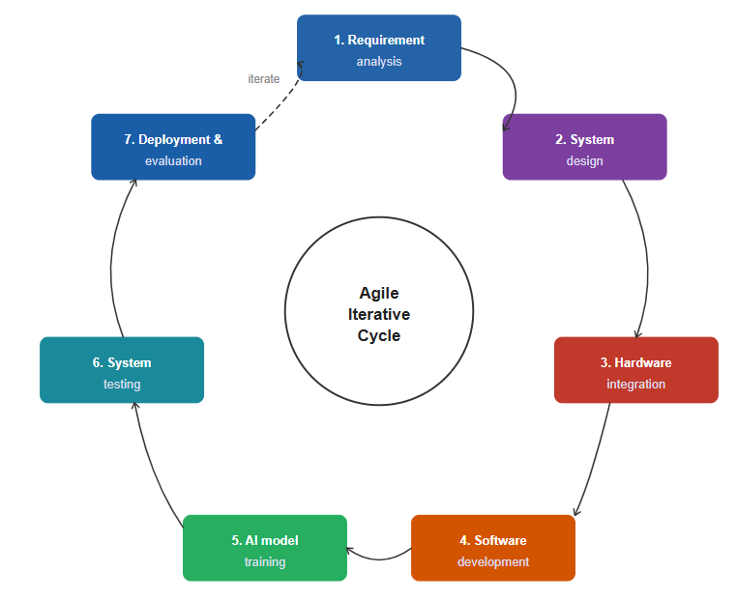
Figure 1 Agile methodology
Frequent testing and evaluation help ensure that the system performs correctly under simulated healthcare monitoring conditions.

3.7 IMPLEMENTATION TIMELINE
The project implementation timeline outlines the planned activities and development phases for the ColdChain Sentinel system.
Table 8 Implementation Timeline
Phase | Activity | Duration
Phase 1 | Literature Review and Requirement Analysis | 2 Weeks
Phase 2 | System Design and Architecture Development | 2 Weeks
Phase 3 | Hardware Integration and Sensor Setup | 3 Weeks
Phase 4 | Cloud Platform and Dashboard Development | 2 Weeks
Phase 5 | AI Model Development and Training | 3 Weeks
Phase 6 | System Testing and Evaluation | 2 Weeks
Phase 7 | Documentation and Final Report Preparation | 2 Weeks

CHAPTER 4: DESIGN AND IMPLEMENTATION

This chapter presents the design and implementation of the ColdChain Sentinel system. It describes the system architecture, requirements, database, and user interface, along with AI and IoT integration. The system is designed to ensure safe vaccine storage through real-time monitoring, prediction, and automated response.

4.1 SYSTEM ARCHITECTURE
The ColdChain Sentinel system follows a multi-layer architecture consisting of the sensing layer, communication layer, application layer, and intelligence layer. The sensing layer contains ESP32 microcontrollers connected to temperature, humidity, and air quality sensors. These sensors continuously collect environmental data from vaccine storage facilities.
The communication layer is responsible for transmitting sensor readings from the IoT devices to the backend server through wireless network connectivity. The application layer processes incoming data, stores information in the database, generates alerts, and provides visualization through the web dashboard.
The intelligence layer contains the LSTM prediction model and the Sentinel AI chatbot. The prediction model analyzes historical temperature data to forecast future storage conditions, while the chatbot provides users with guidance on vaccine handling, storage procedures, and emergency responses based on WHO recommendations.
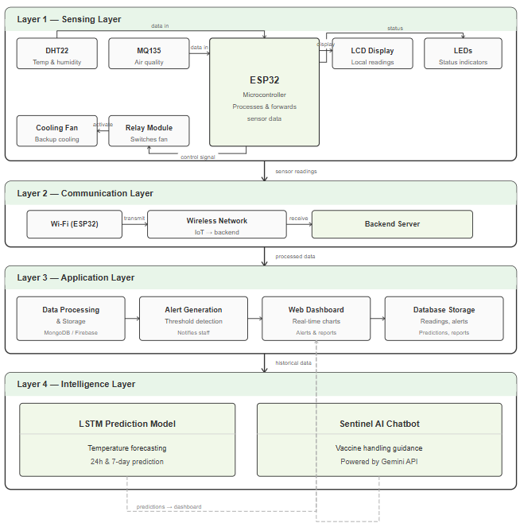
Figure 2 Architecture of the ColdChain Sentinel system

4.2 SYSTEM ACTORS
The system consists of three primary actors.
An admin is responsible for managing the entire platform. This user can manage health centers, users, vaccine storage equipment, reports, and overall system configurations.
The Health Center Manager is responsible for supervising vaccine storage activities within a specific health facility. This user monitors storage conditions, manages vaccine inventories, receives alerts, reviews predictions, generates reports, and interacts with the Sentinel AI chatbot.
The Nurse or Technician is responsible for daily monitoring activities. This user monitors environmental conditions, reviews alerts, checks vaccine information, and consults the chatbot for operational guidance during routine activities and emergencies.
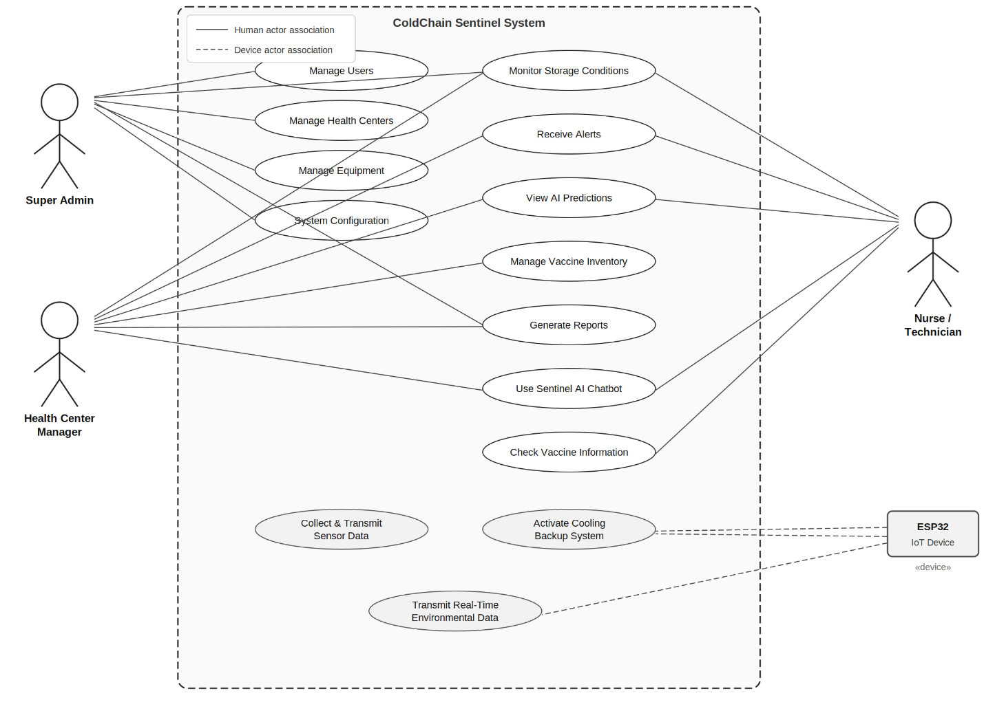
Figure 3 UseCase Diagram of coldchain sentinel

4.3 FUNCTIONAL DESIGN
The ColdChain Sentinel system provides several integrated functions to support vaccine cold chain management.
The user management function enables administrators to create and manage user accounts while controlling system access through role-based permissions. The health center management function allows the registration and monitoring of hospitals, clinics, and health facilities connected to the platform.
The refrigerator and freezer management function allows users to register storage equipment and define acceptable temperature ranges for vaccine preservation.
The IoT monitoring function continuously collects environmental data from sensors and displays real-time information on the dashboard. The vaccine inventory function records vaccine batches, quantities, manufacturers, storage status, and expiry dates. The alert management function automatically detects abnormal environmental conditions and notifies responsible personnel whenever vaccine safety may be compromised.
The prediction function uses artificial intelligence techniques to forecast future temperature trends and identify potential risks before they occur. The Sentinel AI chatbot function assists users by providing instant answers related to vaccine storage, temperature excursions, equipment maintenance, and WHO cold chain guidelines. The reporting function generates historical summaries and analytical reports that support decision making and regulatory compliance.

4.4 DATABASE DESIGN
The system uses MongoDB as its primary database because it provides flexibility for storing large volumes of sensor readings and supports real-time data processing. The database contains collections responsible for managing users, health centers, refrigerators, devices, vaccines, sensor readings, alerts, predictions, reports, and chatbot conversations.
The Users collection stores account information and role assignments. The Health Centers collection stores information about healthcare facilities connected to the system. The Vaccines collection stores vaccine inventory records, while the Sensor Readings collection stores environmental measurements collected from IoT devices. Additional collections are used for alerts, predictions, and chatbot interactions.
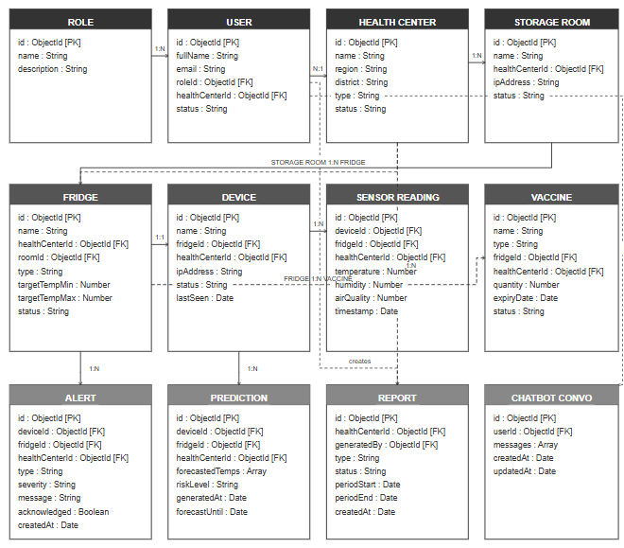
Figure 4 Database schema of the system

4.5 USER INTERFACE IMPLEMENTATION
The ColdChain Sentinel web application was developed to provide an intuitive and user-friendly environment for healthcare workers and administrators. The interface enables users to monitor storage conditions, manage inventories, receive alerts, review predictions, and access intelligent assistance through the chatbot.

4.5.1 Dashboard Page
The dashboard serves as the main entry point of the system. It displays current environmental conditions, equipment status, active alerts, and summary statistics. The dashboard provides users with an overview of vaccine storage conditions across the facility.
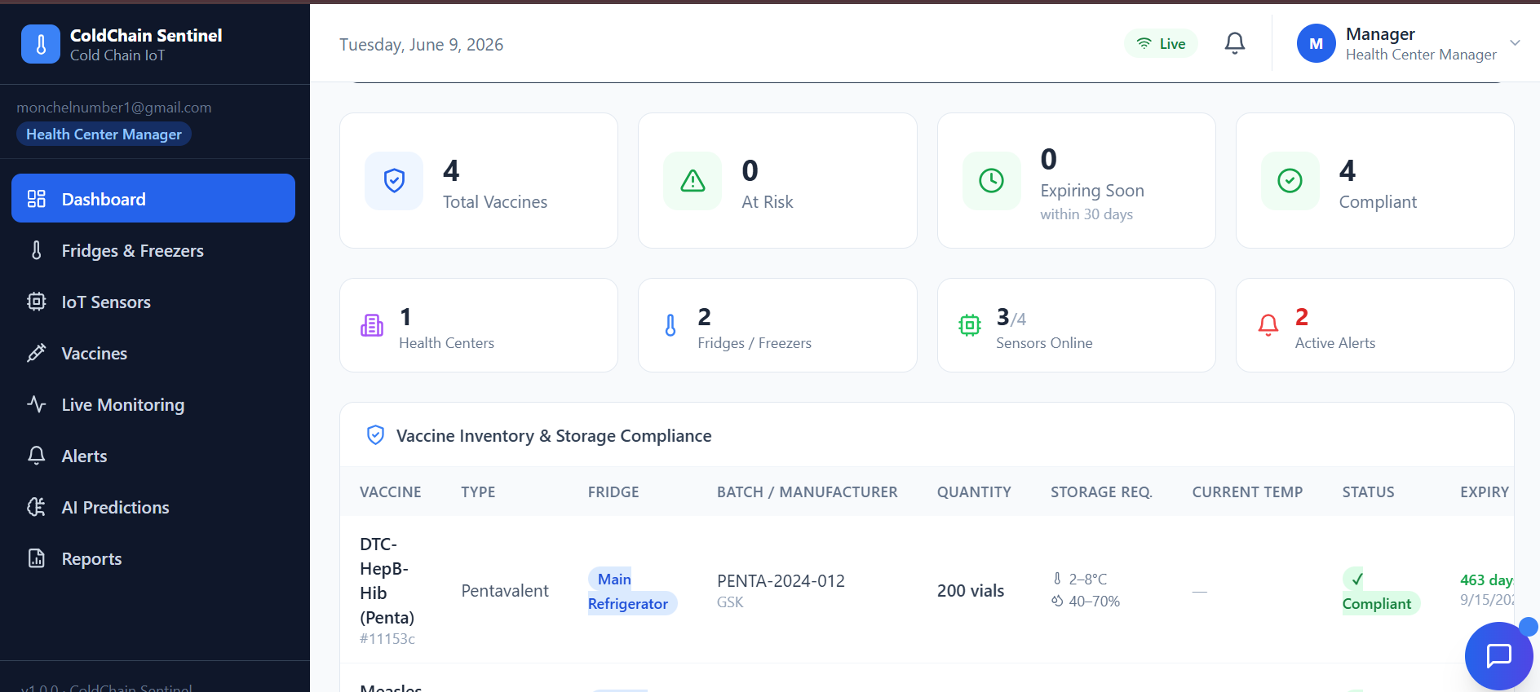
Figure 5 dashboard interface

4.5.2 Health Centers Page
The Health Centers page allows administrators to manage hospitals, clinics, and vaccine storage facilities. Users can view facility information and monitor associated resources.
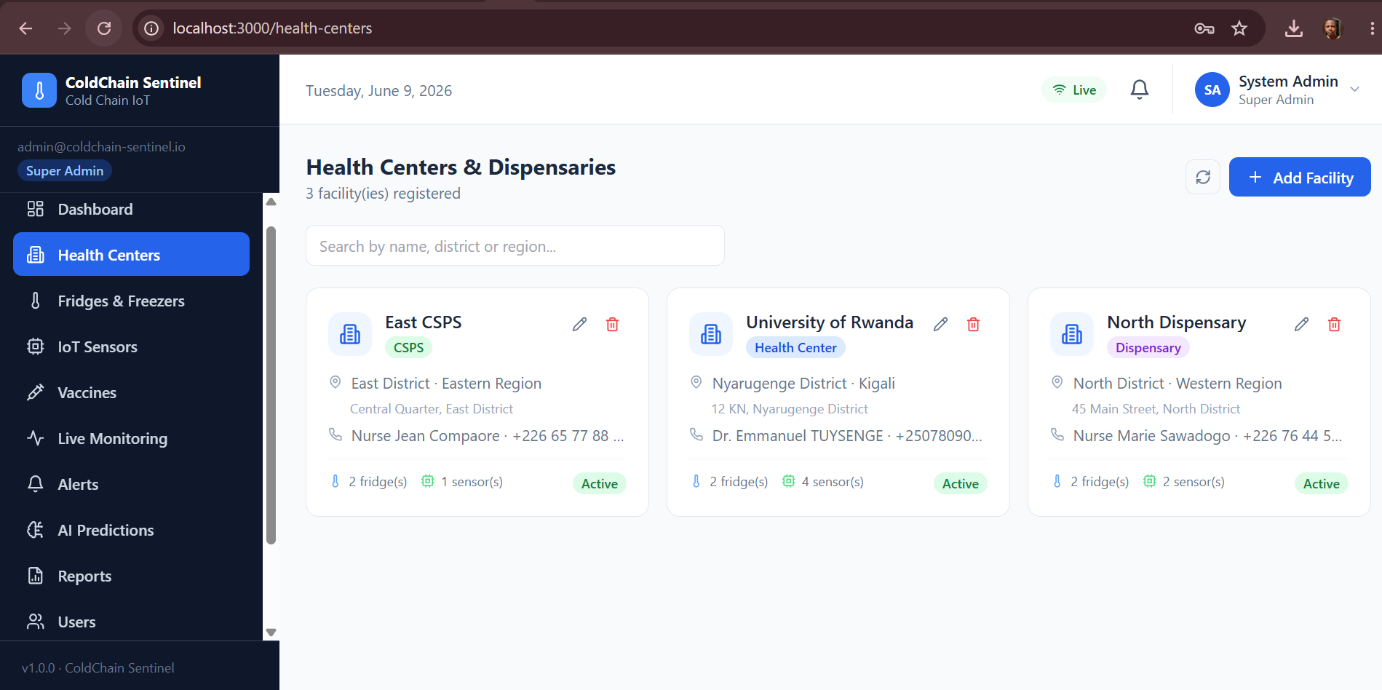
Figure 6 Health Centers page.

4.5.3 Refrigerators and Freezers Page
This page manages vaccine storage equipment. Users can register refrigerators, define acceptable temperature ranges, and monitor equipment status.
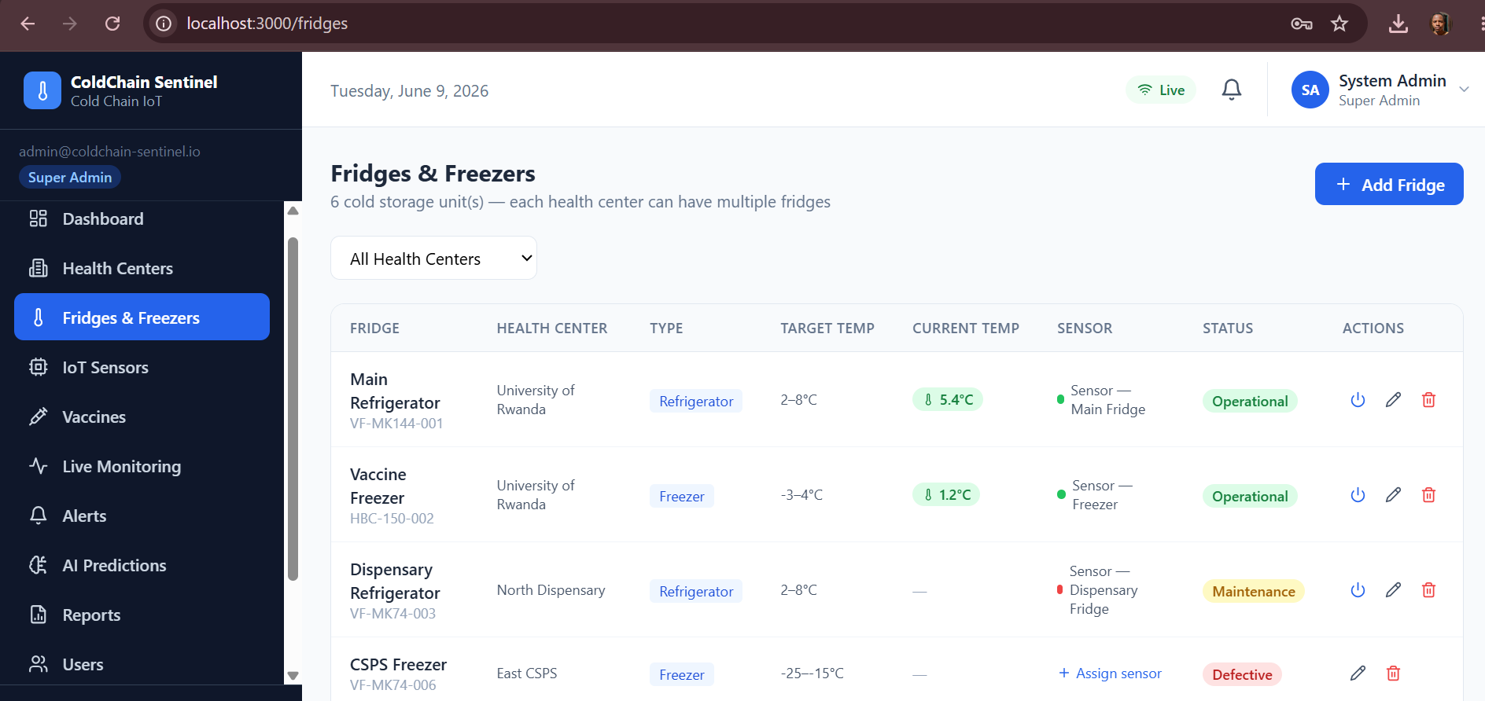
Figure 7 refrigerator management interface

4.5.4 IoT Devices Page
The IoT Devices page displays information about connected ESP32 devices, including connectivity status and sensor activity. This page helps users monitor device health and system reliability.
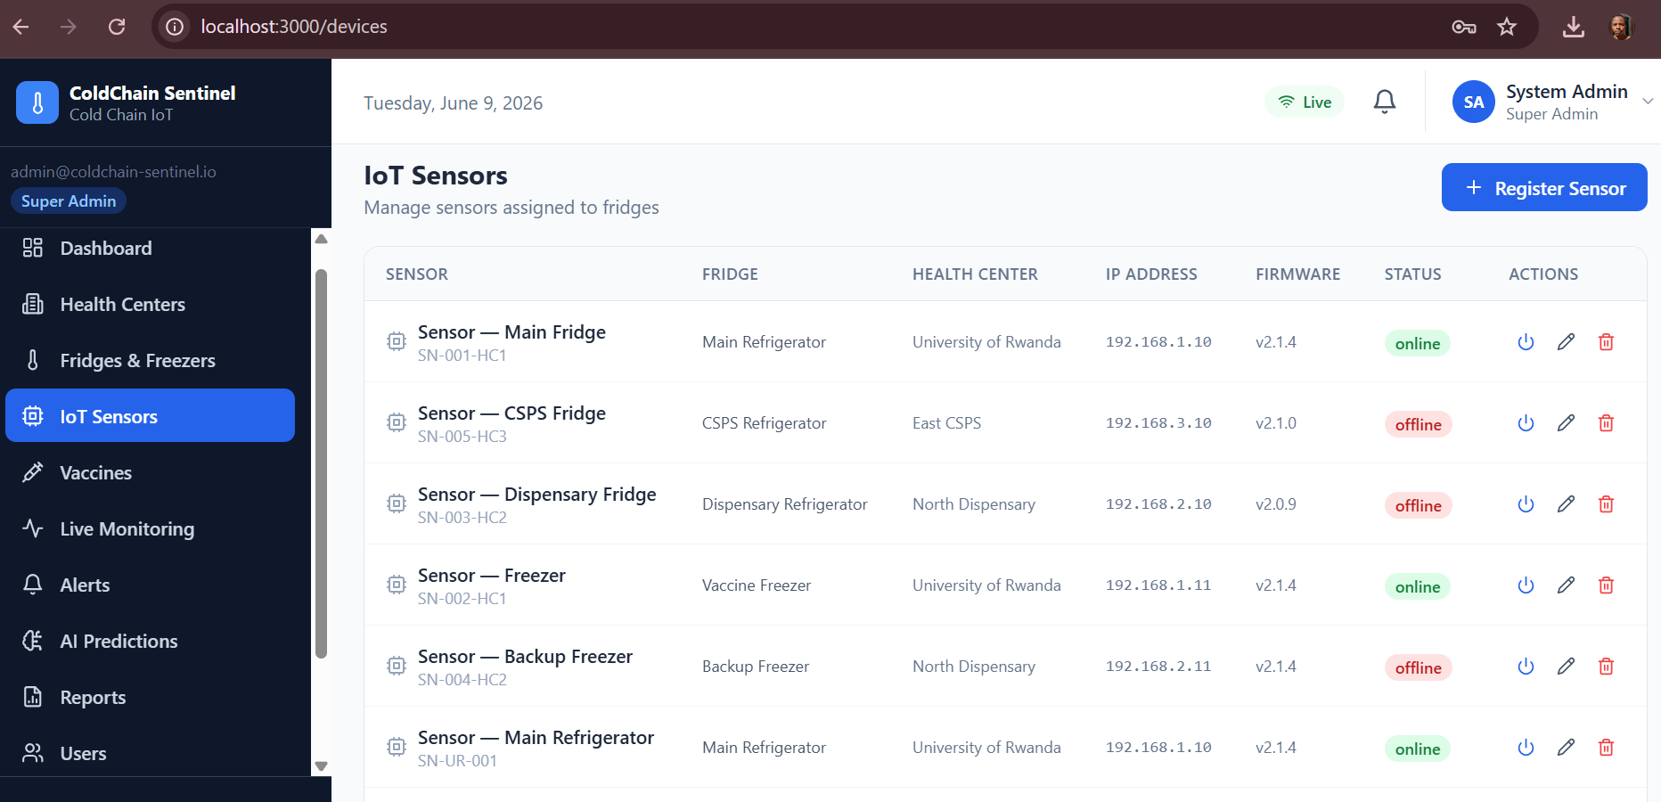
Figure 8 IoT Devices interface

4.5.5 Vaccine Inventory Page
The vaccine inventory page allows users to manage vaccine batches, quantities, manufacturers, and expiry dates. The system automatically tracks inventory status and supports vaccine accountability.
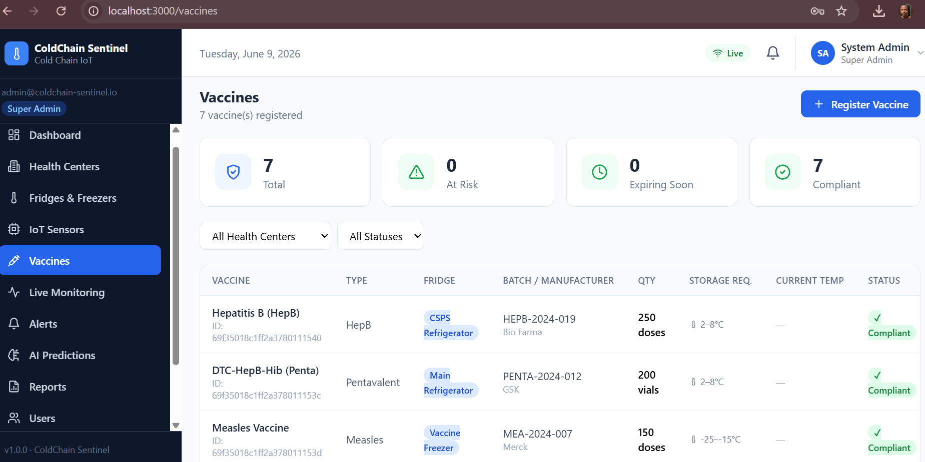
Figure 9 Vaccine management interface

4.5.6 Live Monitoring Page
The live monitoring page provides real-time charts displaying temperature, humidity, and air quality measurements collected from sensors. These visualizations assist users in tracking environmental changes over time.
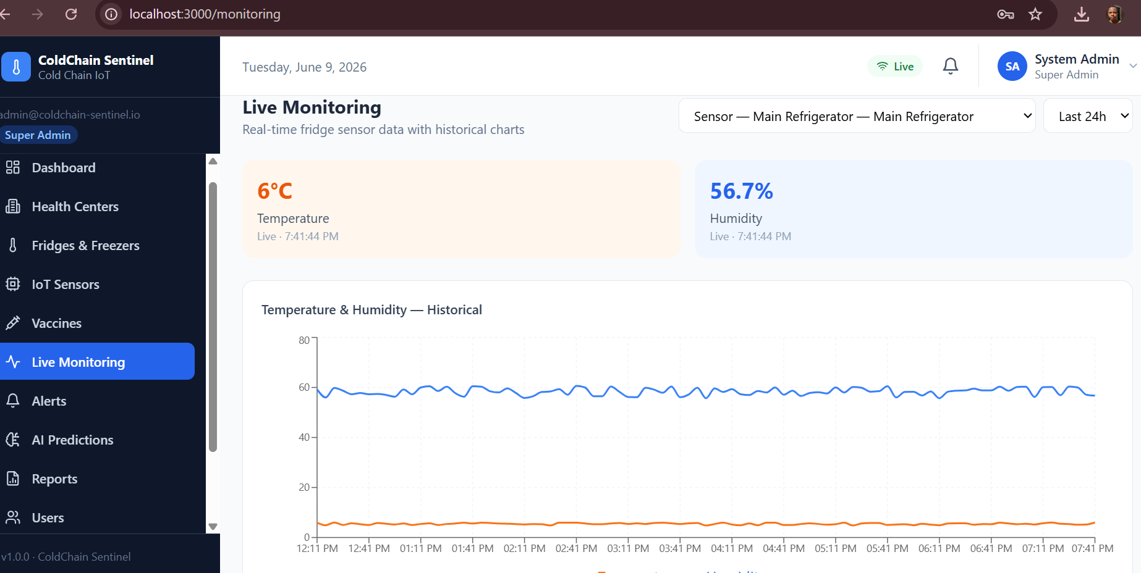
Figure 10 Live monitoring interface

4.5.7 Alerts Page
The alerts page displays active and historical alerts generated by the system. Users can review incidents, acknowledge notifications, and track corrective actions.
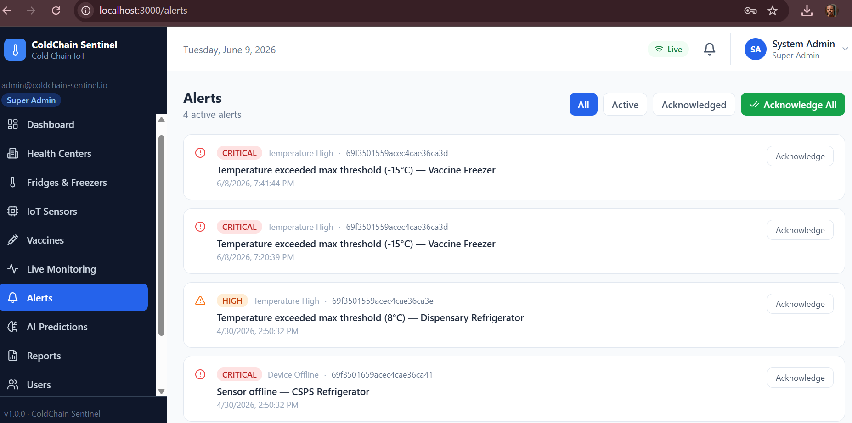
Figure 11 The alerts interface

4.5.8 AI Prediction Page
The prediction page displays future temperature forecasts generated by the LSTM model. These forecasts help users identify potential temperature excursions before they occur.
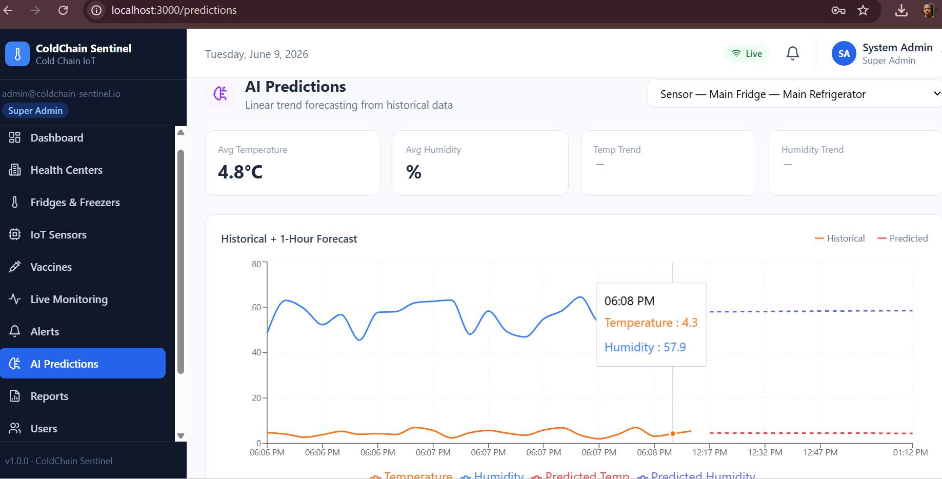
Figure 12 AI prediction interface

4.5.9 Reports Page
The reports page provides analytical summaries and historical records of environmental conditions, alerts, and system activities. Reports support decision making and compliance monitoring.
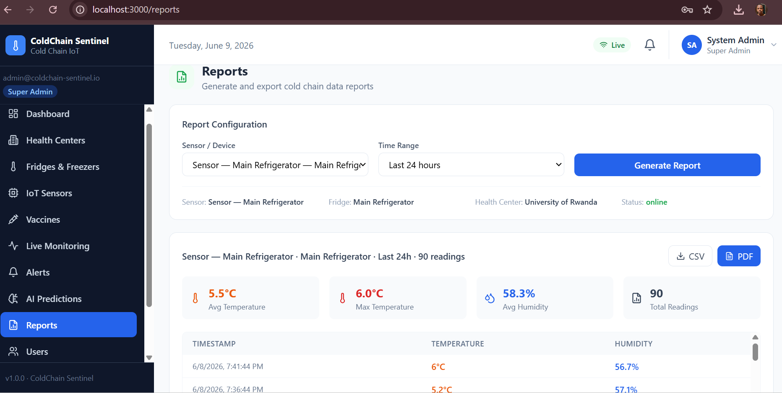
Figure 13 Reports interface

4.5.10 Users Page
The users page allows administrators to manage system accounts and assign appropriate roles and permissions.
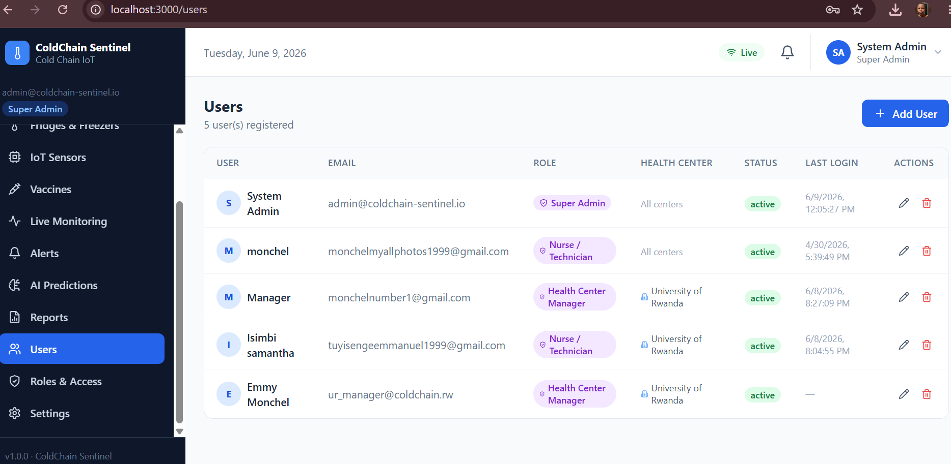
Figure 14 User management interface

4.6 SENTINEL AI CHATBOT
The Sentinel AI chatbot is an intelligent virtual assistant integrated into the ColdChain Sentinel platform through the Gemini API. The chatbot provides healthcare workers with immediate access to information regarding vaccine storage, cold chain maintenance, temperature excursions, equipment handling, and WHO recommendations.
When a user submits a question, the request is processed through the Gemini API, which generates an appropriate response based on the context of vaccine storage and cold chain management. This feature reduces dependency on manuals and provides rapid decision support during emergencies.
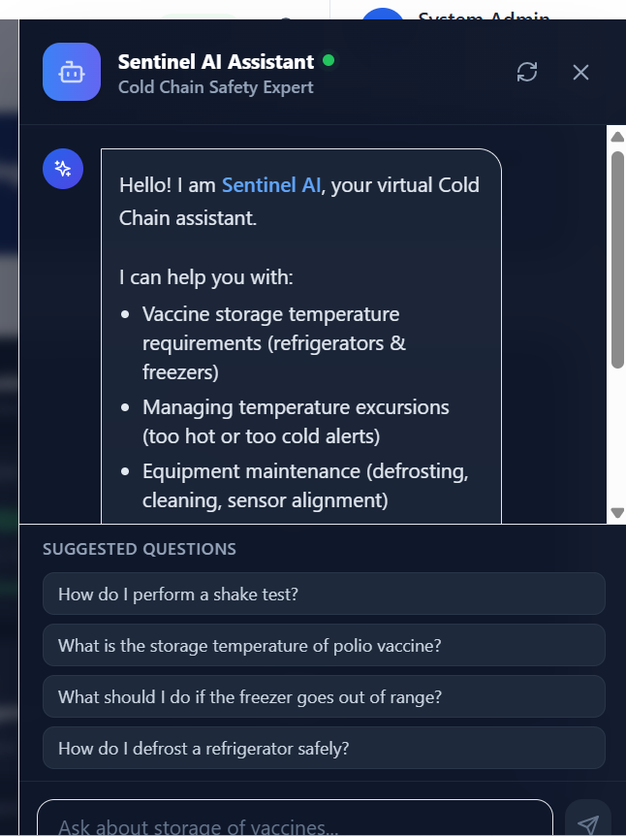
Figure 15 Sentinel AI chatbot interface

4.7 TEMPERATURE PREDICTION MODULE
The ColdChain Sentinel system includes a temperature prediction module developed using a Long Short-Term Memory (LSTM) neural network. Historical temperature readings collected from sensors are used to train the model. After training, the model predicts future temperature values and assists users in identifying risks before vaccine storage conditions become unsafe.
The prediction model supports proactive decision making by enabling health workers to take corrective action before temperature excursions occur.
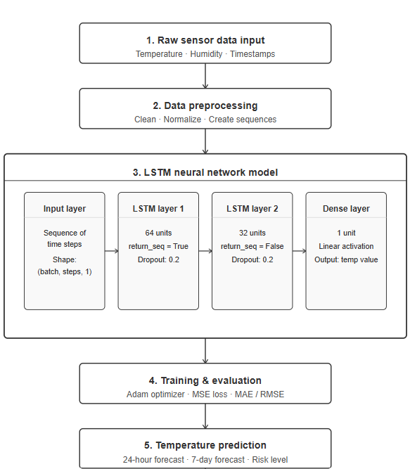
Figure 16 The architecture of the prediction model

4.8 HARDWARE IMPLEMENTATION
The hardware implementation consists of ESP32 microcontrollers, DHT22 temperature and humidity sensors, MQ135 air quality sensors, relay modules, cooling devices, and power supply components. These devices work together to collect environmental data and support automated monitoring activities.
The ESP32 acts as the main processing unit and communication gateway between sensors and the backend server.

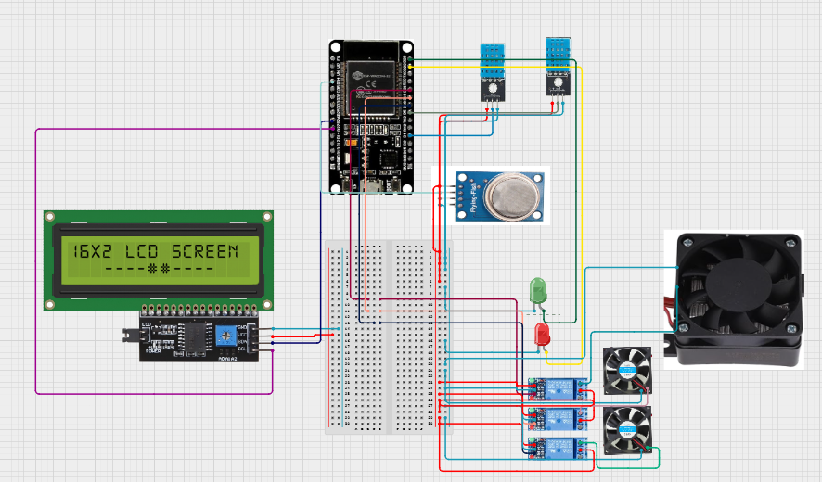
Figure 17 Circuit diagram of device
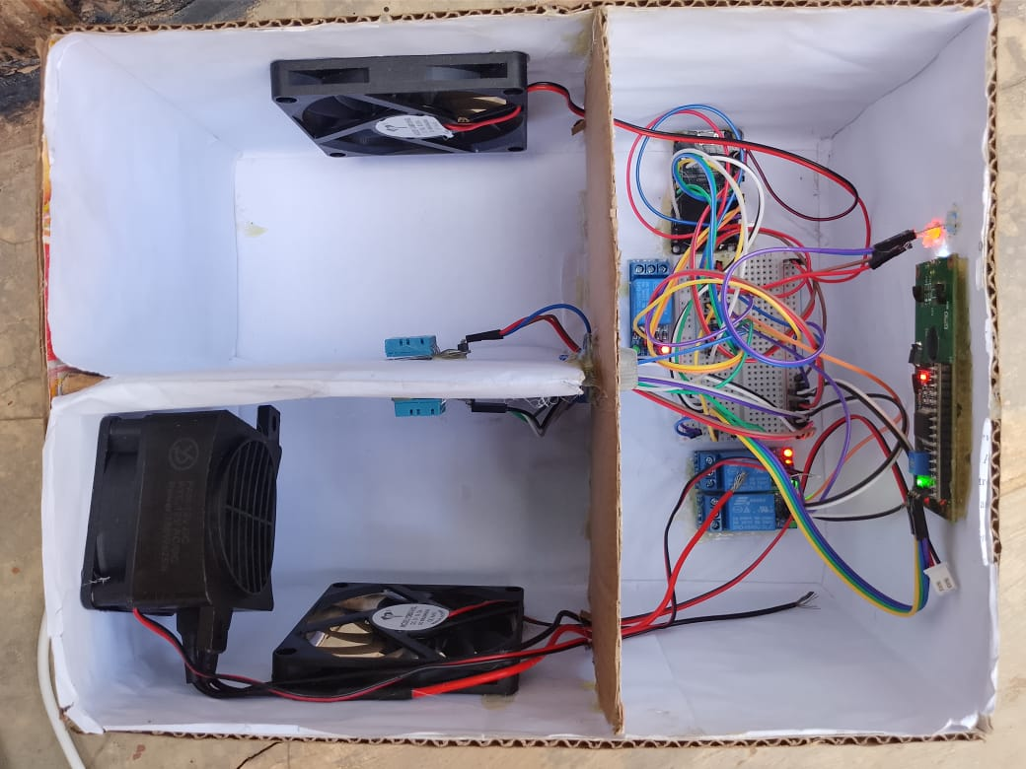
Figure 18 hardware prototype of coldchain sentinel system

CHAPTER 5: DISCUSSION OF THE RESULTS
This chapter presents and discusses the results obtained from the implementation of the ColdChain Sentinel system. The discussion focuses on the performance of the IoT monitoring infrastructure, the web-based management platform, the artificial intelligence prediction model, and the Sentinel AI chatbot. The chapter also evaluates how effectively the developed system achieved the objectives established at the beginning of the research.

5.1 DISCUSSION OF PARAMETERS USED AND THEIR UNITS
Several environmental and operational parameters were monitored throughout the system. These parameters were selected because they directly influence vaccine quality and safety.
Temperature was measured in degrees Celsius (°C). This parameter was the most critical because vaccines must be stored within recommended temperature ranges. For refrigerators, the acceptable range was maintained between 2°C and 8°C, while freezer units operated according to vaccine storage requirements. Humidity was measured as Relative Humidity (RH) expressed as a percentage (%). Humidity monitoring helped assess environmental conditions surrounding vaccine storage equipment. Air quality was measured using the MQ135 sensor. The sensor provided values representing air quality levels within the storage environment. These readings were useful for identifying environmental conditions that could affect equipment performance.
Time was recorded using timestamps measured in date and time format. Timestamps allowed the system to track environmental changes and generate historical records for analysis. Prediction accuracy was measured using machine learning evaluation metrics including Mean Absolute Error (MAE), Mean Squared Error (MSE), and Root Mean Squared Error (RMSE). These metrics were used to evaluate the performance of the LSTM temperature prediction model.

5.2 DISCUSSION OF RESULTANT
This section discusses the results generated by the monitoring system, prediction model, and chatbot components.

5.2.1 Data Preprocessing
Before training the prediction model, historical temperature data collected from the sensors underwent preprocessing. Missing values were handled appropriately, duplicate records were removed, and temperature readings were normalized to improve model performance.The preprocessing stage improved data quality and ensured that the prediction model received consistent and reliable information during training. Figure 5.1 presents the preprocessing workflow used during model development.
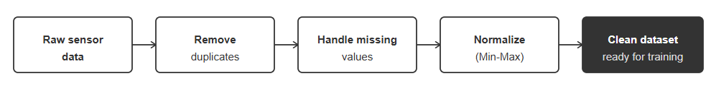
Figure 19 Data Preprocessing Workflow

5.2.2 Training and Validation Accuracy
The training and validation accuracy graph illustrates how the prediction model learned patterns from historical temperature readings during the training process. The graph shows that accuracy improved steadily as training progressed, indicating that the model successfully captured important temperature trends.
The similarity between training and validation accuracy curves demonstrates that the model generalized effectively and avoided significant overfitting.
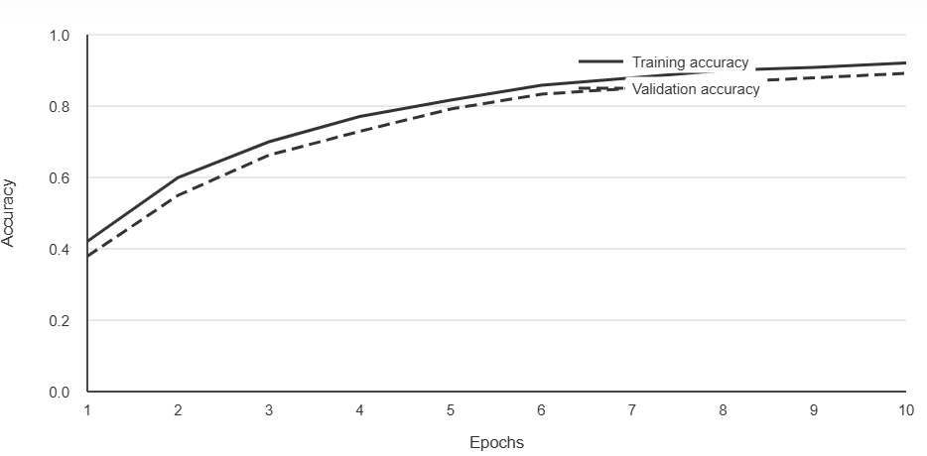
Figure 20 Training and Validation Accuracy Graph

5.2.3 Training and Validation Loss
The training and validation loss graph shows the reduction of prediction errors throughout the training process. Both curves decreased gradually and stabilized after several epochs, indicating successful model convergence. The small difference between training and validation loss suggests that the model maintained good predictive performance on unseen data.
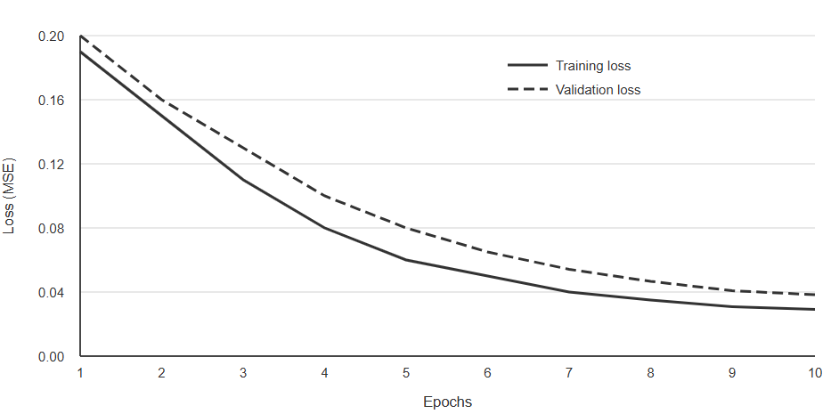
Figure 21 Training and Validation Loss Graph

5.2.4 Prediction Results
The prediction model generated future temperature forecasts using historical environmental data. The forecasted values closely followed actual temperature trends, demonstrating the ability of the model to identify potential temperature excursions before they occurred.
This capability enables healthcare workers to take preventive action before vaccines are exposed to unsafe storage conditions.
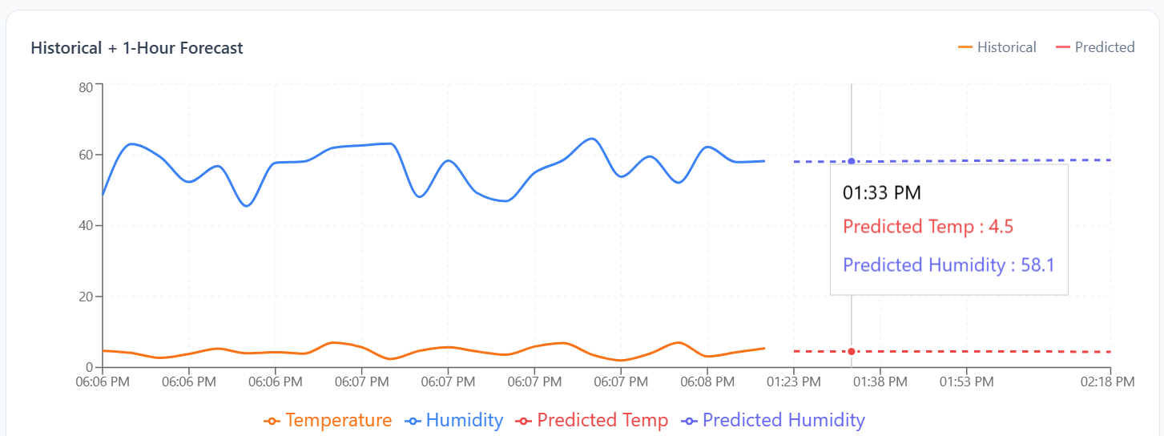
Figure 22 Actual versus Predicted Temperature Graph

5.2.5 Comparison of Prediction Models
Several prediction approaches were evaluated during development. The LSTM model produced more accurate forecasts compared to traditional statistical methods due to its ability to capture long-term dependencies in time-series data.
Table 9 Comparison of Prediction Models
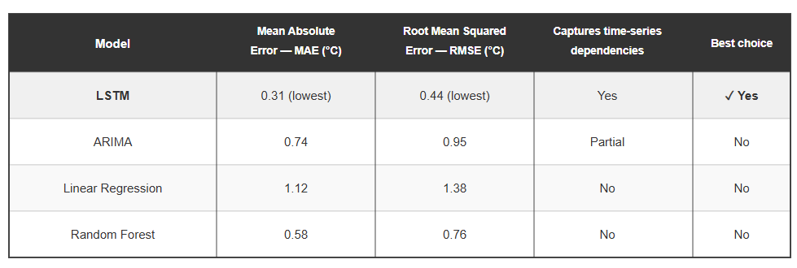

5.3 DISCUSSION OF SYSTEM FUNCTIONAL RESULTS

5.3.1 Web Authentication
The authentication module successfully restricted access based on user roles. Users were required to provide valid credentials before accessing the system. Role-based authorization ensured that administrators, health center managers, and nurses accessed only the functions relevant to their responsibilities. The authentication mechanism improved system security and protected sensitive vaccine monitoring data from unauthorized access.
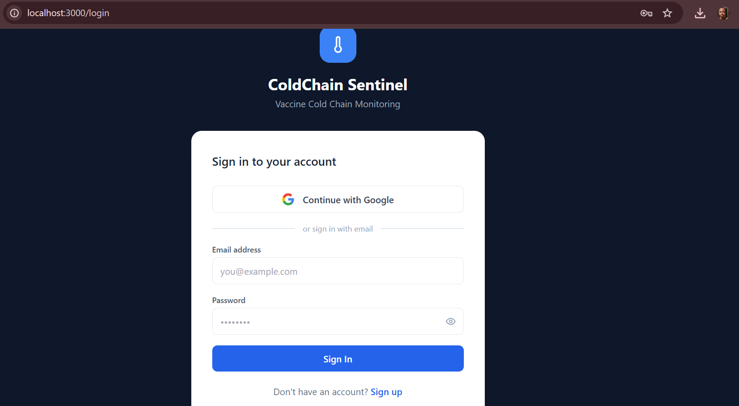
Figure 23 Login Interface

5.3.2 Dashboard Monitoring
The dashboard successfully displayed real-time temperature, humidity, and air quality readings collected from IoT sensors. Users were able to monitor environmental conditions continuously through charts, cards, and summary statistics.
The dashboard provided immediate visibility into storage conditions and allowed healthcare workers to identify abnormal situations quickly.
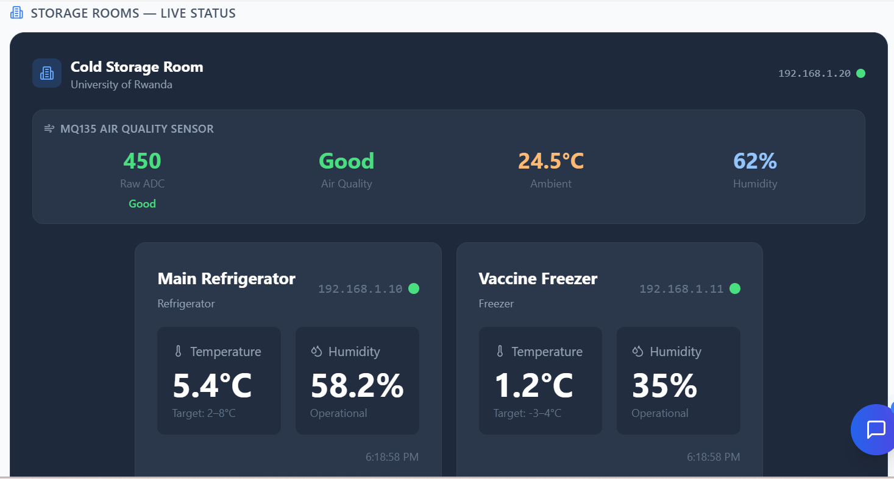
Figure 24 Dashboard Interface

5.3.3 Vaccine Inventory Management
The vaccine inventory module successfully stored and managed information related to vaccine batches, quantities, manufacturers, and expiry dates. Users could track vaccine availability and monitor expiration timelines effectively. The implementation improved inventory visibility and reduced the risk of administering expired vaccines.
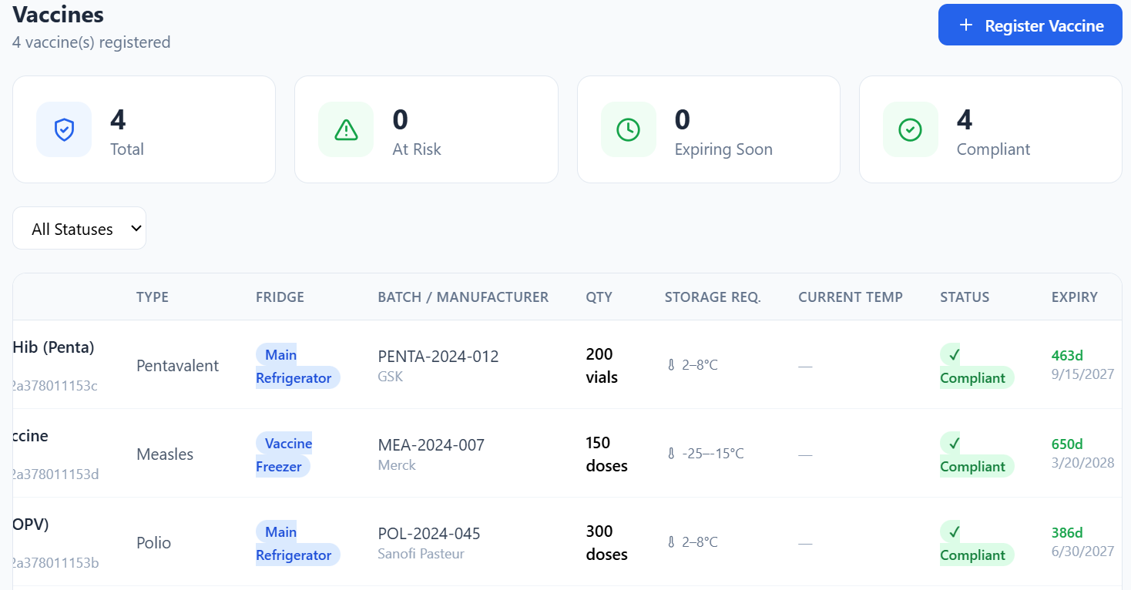
Figure 25 Vaccine Inventory Interface

5.3.4 Alert Management
The alert management module successfully detected unsafe environmental conditions and generated notifications whenever predefined thresholds were exceeded. During testing, alerts were generated whenever temperature readings exceeded the recommended storage range. These alerts enabled rapid intervention and minimized the risk of vaccine spoilage.
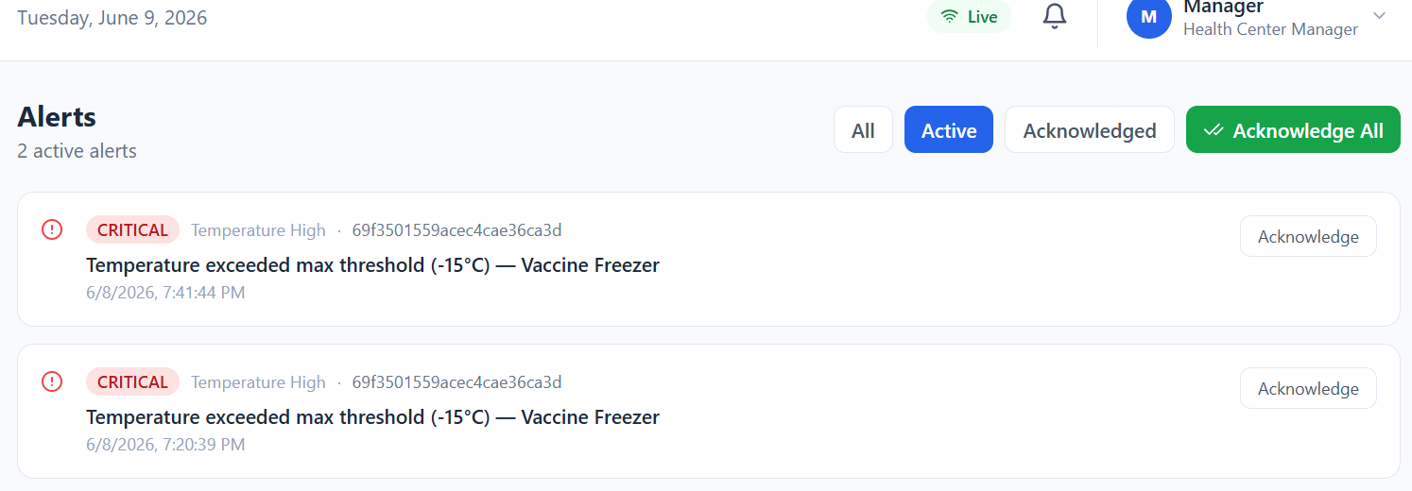
Figure 26 Alert Notification Interface

5.3.5 IoT Monitoring Performance
The ESP32 devices successfully transmitted sensor readings to the backend system through wireless communication. The monitoring infrastructure maintained continuous communication and delivered environmental updates to the dashboard in real time. The implementation demonstrated the suitability of IoT technology for vaccine cold chain monitoring applications.

5.3.6 Sentinel AI Chatbot Performance
The Sentinel AI chatbot successfully responded to user questions related to vaccine storage, cold chain management, temperature excursions, and equipment maintenance. Testing showed that users could obtain guidance immediately without consulting external documentation. The chatbot improved accessibility to technical information and supported decision-making during emergencies.
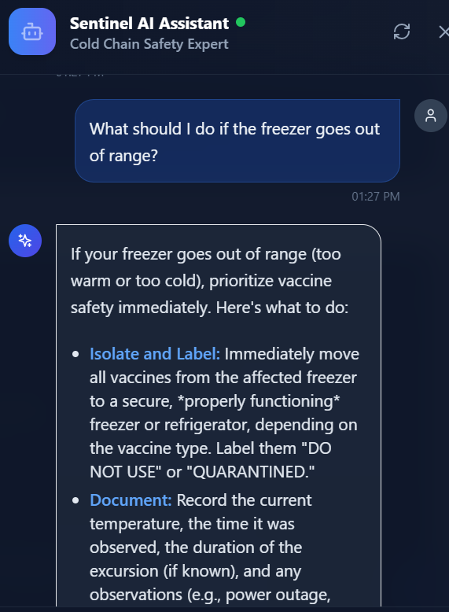
Figure 27 Sentinel AI Chatbot Interface

5.3.7 AI Clinical Advisory Generation
The system successfully generated AI-powered clinical advisories whenever abnormal storage conditions occurred. The advisories provided context-specific recommendations based on the affected vaccines and environmental conditions. This feature enhanced the practical usefulness of the monitoring platform and supported healthcare workers during critical situations.

5.4 DISCUSSION OF OVERALL OUTCOMES
The implementation results demonstrate that the ColdChain Sentinel system successfully achieved its intended objectives. The developed platform continuously monitored environmental conditions, generated alerts, predicted future temperature trends, managed vaccine inventories, and provided intelligent assistance through the Sentinel AI chatbot.
The integration of IoT technology, machine learning, and artificial intelligence improved the ability of healthcare workers to maintain safe vaccine storage conditions. The system also addressed challenges commonly experienced in rural healthcare facilities, including delayed response to temperature excursions and limited access to technical guidance.
Overall, the developed solution proved effective in supporting vaccine safety, reducing spoilage risks, and improving cold chain management practices.

5.5 SUMMARY OF THE PROPOSED PRODUCT
ColdChain Sentinel is a comprehensive IoT-based vaccine monitoring system that combines real-time environmental monitoring, predictive analytics, intelligent alerting, vaccine inventory management, and AI-powered decision support. The system provides healthcare workers with accurate information regarding storage conditions while helping them respond quickly to potential threats to vaccine safety.
The successful implementation and evaluation of the system demonstrate its potential to improve vaccine cold chain management, particularly in rural healthcare environments where maintaining proper storage conditions remains a significant challenge.

CHAPTER 6: CONCLUSION AND RECOMMENDATION
This chapter concludes that the ColdChain Sentinel system was successfully developed to improve vaccine storage using IoT and AI. It provides monitoring, prediction, and alerts to enhance vaccine safety. It also recommends future improvements like more sensors, better notifications, and real-world deployment.

6.1 CONCLUSION
This project successfully designed and implemented ColdChain Sentinel, an IoT-based solution for monitoring vaccine storage conditions in health facilities. The system continuously monitors temperature, humidity, and air quality using IoT sensors and provides real-time data through a web-based dashboard. It also includes a proactive cooling backup mechanism, an AI-powered temperature prediction model, and the Sentinel AI chatbot to assist healthcare workers with vaccine storage and cold chain management.
The results obtained during system testing demonstrated that the proposed solution can effectively monitor environmental conditions, generate alerts when unsafe situations occur, and support timely decision-making. The LSTM prediction model was able to forecast temperature trends, helping users identify potential risks before vaccine storage conditions become critical. In addition, the Sentinel AI chatbot provided quick and relevant guidance related to vaccine safety, storage requirements, and emergency response procedures.
Overall, the project achieved its objectives and demonstrated that integrating IoT technology, artificial intelligence, and web technologies can improve vaccine cold chain management. The system has the potential to reduce vaccine spoilage, improve monitoring efficiency, and support healthcare workers in maintaining vaccine safety, especially in rural areas where power interruptions and monitoring challenges are common.

6.2 RECOMMENDATIONS
Although the developed system achieved its intended objectives, several improvements can be made in future work. First, additional environmental sensors such as power monitoring sensors and door status sensors can be integrated to provide more comprehensive monitoring of vaccine storage facilities. Second, the system can be enhanced by integrating SMS and mobile application notifications to ensure that alerts reach healthcare workers even when they are not actively using the web dashboard. Third, future versions of the project can improve the prediction model by using larger datasets collected over longer periods of time, which may increase forecasting accuracy and reliability. Finally, the system can be deployed and evaluated in multiple health centers and hospitals to assess its performance under real operational conditions and support wider adoption of intelligent vaccine cold chain management solutions.

REFERENCES
[1] S. Jiang, S. Jia, and H. Guo, "Internet of Things (IoT)-enabled framework for a sustainable vaccine cold chain management system," Heliyon, vol. 10, no. 7, p. e28910, Mar. 2024. doi: 10.1016/j.heliyon.2024.e28910
[2] J. B. Kalisa and J. C. Tuyisenge, "Internet of Things remote monitoring solution for efficient storage and delivery of temperature-sensitive vaccines in Rwanda," Diss. College of Science and Technology, University of Rwanda, Kigali, Rwanda, 2021.
[3] F. Uwonkunda, "Smart monitoring system for hospital cold rooms in Rwanda," Undergraduate Thesis, College of Science and Technology, University of Rwanda, Kigali, Rwanda, 2022.
[4] I. Shafi, S. Din, S. Farooq, I. de la Torre Diez, J. Breñosa, J. C. M. Espinosa, and I. Ashraf, "Design and development of patient health tracking, monitoring and big data storage using Internet of Things and real time cloud computing," PLOS ONE, vol. 19, no. 3, p. e0298582, Mar. 2024. doi: 10.1371/journal.pone.0298582
[5] J. D. Nyirimanzi, J. Ngenzi, V. Kagisha, T. Bizimana, and E. Kayitare, "Assessment of medicines cold chain storage conformity with the requirements of the World Health Organization in health facilities of the Eastern Province of Rwanda," J. Pharm. Policy Pract., vol. 16, no. 1, p. 31, Feb. 2023. doi: 10.1186/s40545-023-00534-3
[6] World Health Organization, Immunization Agenda 2030: A Global Strategy to Leave No One Behind. Geneva: WHO, 2023. [Online]. Available: https://www.who.int/immunization/ia2030
[7] C. L. Kok, J. B. Heng, Y. Y. Koh, and T. H. Teo, "Energy-, cost-, and resource-efficient IoT hazard detection system with adaptive monitoring," Sensors, vol. 25, no. 6, p. 1761, Mar. 2025. doi: 10.3390/s25061761
[8] A. Efendi, M. I. Ammarullah, I. G. T. Isa, M. P. Sari, J. N. Izza, Y. S. Nugroho, H. Nasrullah, and D. Alfian, "IoT-based elderly health monitoring system using Firebase cloud computing," Health Sci. Rep., vol. 8, no. 3, p. e70498, Mar. 2025. doi: 10.1002/hsr2.70498
[9] O. Kolawole, J. Okafor, and S. Bello, "Challenges and innovations of vaccine cold chain distribution in developing countries: a narrative review," Int. J. Res. Sci. Innov., vol. 12, no. 12, pp. 1–18, Dec. 2025. doi: 10.51244/IJRSI.2025.1212001
[10] E. A. Nketiah, L. Chenlong, J. Yingchuan, and S. A. Aram, "Recurrent neural network modeling of multivariate time series and its application in temperature forecasting," PLOS ONE, vol. 18, no. 5, p. e0285713, May 2023. doi: 10.1371/journal.pone.0285713
[11] M. M. Khan and M. Alkhathami, "Anomaly detection in IoT-based healthcare: machine learning for enhanced security," Sci. Rep., vol. 14, p. 5872, Mar. 2024. doi: 10.1038/s41598-024-56126-x
[12] A. S. Musleh et al., "Deep learning-driven anomaly detection for IoMT-based smart healthcare systems," Comput. Model. Eng. Sci., vol. 141, no. 3, pp. 2121–2141, Oct. 2024. doi: 10.32604/cmes.2024.054380
[13] D. Hercog, T. Lerher, M. Truntč, and O. Težak, "Design and implementation of ESP32-based IoT devices," Sensors, vol. 23, no. 15, p. 6739, Jul. 2023. doi: 10.3390/s23156739
[14] D. A. Pradeesh and N. P. Subiramaniyam, "IoT-enabled smart health monitoring system with deep learning models for anomaly detection and predictive health risk analytics integrated with LoRa technology," Int. J. Eng. Trends Technol., vol. 73, no. 1, pp. 14–46, Jan. 2025. doi: 10.14445/22315381/IJETT-V73I1P102
[15] N. H. Rahman, M. H. Lee, and M. F. Hamid, "IoT-based real-time temperature monitoring in critical systems: a review," IgMin Res., vol. 3, no. 5, pp. 1–15, May 2025. doi: 10.61927/igmin303
[16] A. Hakami, "IoT-enabled real-time vaccine storage monitoring and alert system," in Proc. IEEE Int. Conf. Comput. Commun. Eng., 2024, pp. 1–6. doi: 10.1109/ICCCE2024.11012249
[17] J. H. Lee et al., "Design and development of an IoT based smart vaccine carrier and real-time monitoring system," in Proc. IEEE Int. Conf. Consum. Electron., 2025, pp. 1–5. doi: 10.1109/ICCE.2025.10951133
[18] T. Liu and X. Li, "Research on temperature prediction based on LSTM," Acad. J. Sci. Technol., vol. 6, no. 3, pp. 54–55, Jul. 2023. doi: 10.54097/ajst.v6i3.10325
[19] Y. Wang et al., "TE-LSTM: A prediction model for temperature based on multivariate time series data," Remote Sens., vol. 16, no. 19, p. 3666, Oct. 2024. doi: 10.3390/rs16193666
[20] S. H. Yakobi et al., "AI-predictive vaccine stability: a systems biology framework to modernize regulatory testing and cold chain equity," npj Vaccines, vol. 10, no. 1, p. 158, Sep. 2025. doi: 10.1016/j.vaccine.2025.01.158
[21] A. B. Morid, O. R. L. Sheng, and J. Dunbar, "Time series prediction using deep learning methods in healthcare," ACM Trans. Manage. Inf. Syst., vol. 14, no. 1, pp. 1–29, Jan. 2023. doi: 10.1145/3531326
[22] T. S. Amara, I. Mukherjee, K. K. Mishra, and P. R. Kumar, "Machine learning and IoT in healthcare: recent advancements, challenges and future directions," Internet Things, vol. 29, p. 101392, Mar. 2025. doi: 10.1016/j.iot.2025.101392
[23] W. Yusuf et al., "IoT-based water quality monitoring system using ESP32," in Proc. IEEE Int. Conf. Innov. Intell. Informatics Comput. Technol., 2024, pp. 1–6. doi: 10.1109/ICIIICT.2024.11139802
[24] M. A. Al-Garadi, A. Mohamed, A. K. Al-Ali, X. Du, I. Ali, and M. Guizani, "A survey of machine and deep learning methods for Internet of Things (IoT) security," IEEE Commun. Surv. Tutor., vol. 22, no. 3, pp. 1646–1685, 2020. doi: 10.1109/COMST.2020.2988293
[25] S. Musa, A. Haruna, B. Aliyu, A. Zubairu, and D. O. Lucero-Prisno, "Leveraging AI to optimize vaccines supply chain and logistics in Africa: opportunities and challenges," Front. Pharmacol., vol. 16, p. 1531141, Jan. 2025. doi: 10.3389/fphar.2025.1531141
[26] A. K. Sangaiah, A. Thangavelu, and V. M. Sundaram, Cognitive Computing for Big Data Systems Over IoT: Frameworks, Tools and Applications. Cham: Springer, 2023. doi: 10.1007/978-3-319-70688-7
[27] K. Biswas, V. Muthukkumarasamy, G. Bai, and M. J. M. Chowdhury, "A reliable vaccine tracking and monitoring system for health clinics using blockchain," Sci. Rep., vol. 13, p. 567, Jan. 2023. doi: 10.1038/s41598-022-26029-w
[28] M. Ragab and S. S. Binyamin, "Intelligent energy-aware thermal exchange optimization with deep learning model for IoT-enabled smart healthcare," Comput. Intell. Neurosci., vol. 2023, p. 3830857, Jul. 2023. doi: 10.1155/2023/3830857
[29] B. Alrawais, A. Alhothaily, C. Hu, and X. Cheng, "Fog computing for the Internet of Things: security and privacy issues," IEEE Internet Comput., vol. 21, no. 2, pp. 34–42, 2023. doi: 10.1109/MIC.2017.37
[30] R. Pellegrino et al., "Revolutionize cold chain: an AI/ML driven approach to overcome capacity shortages," Int. J. Prod. Res., vol. 62, no. 7, pp. 2190–2212, Sep. 2024. doi: 10.1080/00207543.2024.2398583
[31] F. Mwita, A. Kavishe, and E. Mselle, "Vaccine handling practices and conformity to cold chain temperature requirements in selected regions of Tanzania: a descriptive cross-sectional study," Glob. Health Action, vol. 18, no. 1, p. 2479062, Mar. 2025. doi: 10.1080/16549716.2025.2479062
[32] A. C. Tamba et al., "A novel cloud-based IoT framework for secure health monitoring," Sustainability, vol. 16, no. 3, p. 1349, Feb. 2024. doi: 10.3390/su16031349
[33] H. Pham, N. T. Nguyen, and T. L. Nguyen, "Deep learning-based IoT system for remote monitoring and early detection of health issues in real-time," Sensors, vol. 23, no. 11, p. 5204, May 2023. doi: 10.3390/s23115204

APPENDICES

